
Typology Approach
for Building Stock
Energy Assessment

Application of Building Typologies
for Modelling the Energy Balance
of the Residential Building Stock

– TABULA Thematic Report N° 2 –

TABULA Project Team
February 2012
www.building-typology.eu

(Deliverable D8)


Contract N°: IEE/08/495
Coordinator: Institut Wohnen und Umwelt, Darmstadt / Germany
Project duration: June 2009 - May 2012

The sole responsibility for the content of this publication lies with the authors.
It does not necessarily reflect the opinion of the European Communities.
The European Commission is not responsible for any use that may be made of the information contained therein.

Authors:

Nikolaus Diefenbach (ed.)  Tobias Loga (ed.) | IWU  (P 01) | Institut Wohnen und Umwelt / Institute for Housing and Environment | Darmstadt /  Germany
Elena Dascalaki  Costas Balaras | NOA  (P 02) | GRoup Energy Conservation  National Observatory of Athens  Institute of Environmental Research and Sustainable Development | Athens /  Greece
Marjana Šijanec Zavrl  Andraž Rakušček | ZRMK  (P 03) | Building and Civil Engineering Institute ZRMK | Ljubljana, Slovenia
Vincenzo Corrado  Stefano Corgnati  Ilaria Ballarini | POLITO  (P 04) | Politecnico di Torino – Energy Department | Torino /  Italy
Nele Renders | VITO  (P 07) | Flemish Institute of Technological Research | Mol /  Belgium
Tomáš Vimmr | STU-K  (P 12) | STU-K | Prague /  Czech Republic
Kim B. Wittchen  Jesper Kragh | SBi  (P 13) | Danish Building Research Institute, AAU | Hørsholm / Denmark

published by
Institut Wohnen und Umwelt GmbH
Rheinstraße 65 / D-64295 Darmstadt / GERMANY
www.iwu.de

IWU order code 01/12
ISBN 978-3-941140-23-3
February 2012

TABULA website: www.building-typology.eu

Contents

1 Summary 5
2 Belgium 6
2.1 Building Typology Approach 6
2.2 Available Data 7
2.3 Energy Balance Method 9
2.4 Energy Balance of the Residential Building Stock 9
2.5 Comparison to National Statistical Data of the Residential Building Stock 11
2.6 Calculation of Energy Saving Potentials 11
2.7 Perspectives and Conclusions 12
3 Czech Republic 13
3.1 Building Typology Approach 13
3.2 Available Data 14
3.3 Energy Balance Method 19
3.4 Energy Balance of the Residential Building Stock 19
3.5 Comparison to National Statistical Data of the Residential Building Stock 20
3.6 Calculation of Energy Saving Potentials 21
3.7 Perspectives and Conclusions 22
4 Denmark 23
4.1 Building Typology Approach 23
4.2 Available Data 23
4.3 Energy Balance Method 24
4.4 Energy Balance of the Residential Building Stock 24
4.5 Comparison to National Statistical Data of the Residential Building Stock 27
4.6 Calculation of Energy Saving Potentials 28
4.7 Perspectives and Conclusions 29
5 Germany 30
5.1 Building Typology Approach 30
5.2 Available Data 30
5.3 Energy Balance Method 32
5.4 Energy Balance of the Residential Building Stock 33
5.5 Comparison to National Statistical Data of the Residential Building Stock 34
5.6 Calculation of Energy Saving Potentials 35
5.7 Perspectives and Conclusions 36

6 Greece 37
6.1 Building Typology Approach 37
6.2 Available Data 37
6.3 Energy Balance Method 41
6.4 Energy Balance of the Residential Building Stock 42
6.5 Comparison to National Statistical Data of the Residential Building Stock 44
6.6 Calculation of Energy Saving Potentials 45
6.7 Perspectives and Conclusions 48
7 Italy 50
7.1 Building Typology Approach 50
7.2 Available Data 51
7.3 Energy Balance Method 55
7.4 Energy Balance of the Residential Building Stock 57
7.5 Comparison to National Statistical Data of the Residential Building Stock 58
7.6 Calculation of Energy Saving Potentials 59
7.7 Perspectives and Conclusions 61
8 Slovenia 63
8.1 Building Typology Approach 63
8.2 Available Data 64
8.3 Energy Balance Method 67
8.4 Energy Balance of the Residential Building Stock 68
8.5 Comparison to National Statistical Data of the Residential Building Stock 69
8.1 Calculation of Energy Saving Potentials 70
8.2 Perspectives and Conclusions 72

Summary

Building typologies can serve as a basis for analysing the national housing sector. During the TABULA project which was introducing or further developing building typologies in thirteen EU countries, six of the European partners have carried out model calculations which aim at imaging the energy consumption and estimating the energy saving potentials of their national residential building stocks (IWU / Germany, NOA / Greece, POLITO / Italy, VITO / Belgium, STU-K / Czech Republic, SBi / Denmark).
The partners were choosing different modelling approaches depending on the available statistical data. Some defined a set of synthetical buildings reflecting building stock averages, others were applying a set of “generic” example buildings from the national TABULA typologies.
The results show that the model calculations can provide plausible projections of the energy consumption of the national residential buildings stock. The fit of model calculations and national energy statistics is satisfactory, deviations can often be explained and corrected by adapting standard boundary conditions of the applied calculation models to more realistic values.
Some partners made estimations of possible energy savings, e.g. by applying “standard” or “advanced” packages of energy saving measures to the whole building stock. In that way high potentials of energy savings and CO₂ reduction in the residential building sector could be documented.

In general, the analysis shows that building typologies can be a helpful tool for modelling the energy consumption of national building stocks and for carrying out scenario analysis beyond the TABULA project. The consideration of a set of representative buildings makes it possible to have a detailed view on various packages of measures for the complete buildings stock or for its sub-categories. The effects of different insulation measures at the respective construction elements as well as different heat supply measures including renewable energies can be considered in detail.
The quality of future model calculations will depend very much on the availability of statistical data. For reliable scenario analysis information is necessary about the current state of the building stock (How many buildings and heating systems have been refurbished until now?) and about the current trends (How many buildings and heating systems are being refurbished every year?). The availability and regular update of the relevant statistical data will be an important basis for the development and evaluation of national climate protection strategies in the building sector.

Belgium
(by TABULA partner Vito / Belgium)

In Chapter 5 of our national scientific TABULA report [TAB2011], we described two detailed methodologies to estimate policy scenarios of residential energy use for heating and sanitary hot water by starting from a detailed, representative dataset of the dwelling stock. To model the Energy Balance of the Belgian, residential building stock we extended the ‘Flemish model for residential energy consumption’ (engineering model) with the two other Belgian regions, namely Wallonia and Brussels. We would like to point out that this extension contains the first steps in the integration of the three Belgian regions. Further development of the Belgian model is required to obtain more realistic results for Wallonia and Brussels.

As mentioned before, we use average datasets for representative housing to identify representative dwelling categories, which differ significantly from typical homes, in the sense that characteristics of the building geometry, construction elements and technical installations cannot, or can rarely, be mapped with a physical representation as found in an actual existing house.

In the next paragraphs, we will describe building characteristics and resulting energy consumption of six representative, building categories (base year 2006). These 6 types are obtained by aggregating/averaging the 216 dwelling categories of our original, detailed dwelling stock. The methodology and data sources of the latter, detailed model are described in Chapter 5 of our national scientific TABULA report [TAB2011].

Building Typology Approach

The analysis of the Belgian building stock of the year 2006 starts from a detailed dwelling stock comprising 216 representative dwelling categories (see Chapter 5 of our national scientific TABULA report [TAB2011]). This subdivision is based on:
- Dwelling age: <1945; 1946-1970; 1971-1990; 1991-2006;
- Type of dwelling: freestanding, semi-detached, terraced, flat;
- Type of heating installation: collective central, individual central, decentral ;
- Fuel type for space heating: natural gas, fuel oil, electricity, coal, LPG, wood.

For each category, average energy related characteristics are mapped, based on a lot of data sources which are described in Chapter 5 of our national scientific TABULA report [TAB2011]. For Flanders, these characteristics represent as much as possible the actual situation by using typical Flemish statistics. For Wallonia and Brussels, further development is required to obtain more representative results: so far, the number of housing units for each dwelling category is derived from regional statistics, but the corresponding energy characteristics of each type are copied from Flanders.

The properties of the 216 categories are averaged to obtain 6 representative dwelling types, which cover three dwelling ages (<1970, 1970-1990, 1991-2006) and two building sizes (single family or multi family house). Table 1 summarizes the frequencies of these 6 categories for Belgium expressed by number of housing units.

Table 1. Frequencies of the 6 aggregated, representative dwelling types in Belgian stock for the year 2006.
 |  | Building period | Number of housing units
Single Family Houses | SFH I | until 1970 | 2 126 913
 | SFH II | 1970-1990 | 810 024
 | SFH III | 1991-2006 | 392 813
Multi Family Houses | MFH I | until 1970 | 656 743
 | MFH II | 1970-1990 | 319 895
 | MFH III | 1991-2006 | 216 397
TOTAL |  |  | 4 522 784

Available Data

Besides the frequency of each dwelling category, energy characteristics of dwellings like insulation level (U-value of roof, wall, floor ,window), dimensions of the building envelope and system efficiencies of heating installations are required to model the residential, energy consumption. In Belgium, the primary data sources of building data are:
- General Socio-economic Survey performed in 2001 by the National Institute of Statistics NIS [NIS2001];
- Energy Advice Procedure database [EAP2011].
In Table 2,Table 3 and Table 4, you can find some important characteristics of the building envelope and the heating installations. As already mentioned, these characteristics are based on Flemish statistics. For Wallonia and Brussels, we assume the same properties - but different frequencies - for each dwelling category.

Table 2. Average properties of building envelope for the 6 representative dwelling types (per housing unit, year 2006).
Per housing unit |  | SFH I | SFH II | SFH III | MFH I | MFH II | MFH III
Building Dimensions
Total building envelope area | m² | 422,56 | 477,79 | 477,89 | 90,79 | 95,91 | 97,56
Compactness |  | 1,51 | 1,36 | 1,36 | 3,00 | 3,00 | 3,00
% floor area | % | 25% | 27% | 26% | 22% | 22% | 22%
% wall area | % | 37% | 33% | 33% | 43% | 43% | 43%
% window area | % | 10% | 9% | 10% | 14% | 14% | 14%
% roof area | % | 29% | 31% | 30% | 22% | 22% | 22%
Average U-value
U-value floor | W/m²K | 1,04 | 0,95 | 0,76 | 1,00 | 0,85 | 0,58
U-value wall | W/m²K | 1,89 | 1,56 | 0,81 | 1,78 | 1,52 | 0,78
U-value window | W/m²K | 3,91 | 3,53 | 2,53 | 3,99 | 3,67 | 2,47
U-value roof | W/m²K | 1,86 | 1,32 | 0,69 | 1,92 | 1,36 | 0,57

As you can see in the next tables, individual, central heating installations on natural gas and fuel oil are the most common heating installation within Belgium. On the other hand, district heating and heat pumps are very rarely applied in 2006.
Table 3. Overview of heating installations for 6 representative dwelling types per fuel type (% of number of housing units per fuel type, year 2006).
Energy Carrier | Heat generator |  | SFH I | SFH II | SFH III | MFH I | MFH II | MFH III
Natural Gas | Central | Individual | 26,0% | 14,8% | 12,7% | 7,2% | 4,4% | 7,9%
 |  | Collective |  |  |  | 2,4% | 1,5% | 1,2%
 | Decentral |  | 15,3% | 1,8% | 0,5% | 3,3% | 0,6% | 0,4% | 100%
Fuel oil | Central | Individual | 43,0% | 23,6% | 9,8% | 2,5% | 0,9% | 0,5%
 |  | Collective |  |  |  | 4,8% | 1,9% | 0,4%
 | Decentral |  | 10,2% | 1,4% | 0,4% | 0,4% | 0,1% | 0,1% | 100%
Wood | Central |  | 9,2% | 5,5% | 2,4% | 1,0% | 0,6% | 0,4%
 | Decentral |  | 54,0% | 17,9% | 6,8% | 1,6% | 0,4% | 0,3% | 100%
LPG | Central |  | 18,1% | 6,1% | 4,9% | 2,1% | 1,1% | 0,9%
 | Decentral |  | 52,9% | 7,6% | 2,4% | 2,8% | 0,7% | 0,3% | 100%
Coal | Central |  | 5,6% | 1,9% | 0,3% | 0,6% | 0,3% | 0,2%
 | Decentral |  | 77,2% | 9,7% | 1,6% | 2,2% | 0,4% | 0,1% | 100%
Electricity | Direct |  | 19,3% | 29,3% | 12,3% | 9,9% | 9,7% | 19,5%
 | Heat pump |  |  |  |  |  |  |  | 100%

Table 4 summarizes the frequencies of the different fuel types for the 6 dwelling categories. These frequencies are derived from regional specific statistics [NIS2001] for Flanders, Wallonia and Brussels, and updated based on [REN2011].

Table 4. Overview of fuel types for 6 representative dwelling types (% of total number of housing units, year 2006)
Energy carrier | TOTAL | SFH I | SFH II | SFH III | MFH I | MFH II | MFH III
Natural gas | 49% | 21% | 7% | 4% | 9% | 4% | 3%
Fuel oil | 39% | 21% | 8% | 3% | 4% | 2% | 0%
Coal | 2% | 2% | 0% | 0% | 0% | 0% | 0%
LPG | 1% | 1% | 0% | 0% | 0% | 0% | 0%
Electricity | 7% | 1% | 2% | 1% | 1% | 1% | 1%
Wood | 1% | 1% | 0% | 0% | 0% | 0% | 0%
Total | 100% | 47% | 18% | 9% | 15% | 7% | 5%

Besides the above presented information, other data like a detailed age subdivision of the heating installation stock and the corresponding system efficiencies, a distribution among insulation classes of each dwelling category, types of SHW installation etc. are also available in our detailed engineering model.

Energy Balance Method

To model the Energy Balance of the Belgian, residential building stock we extended the ‘Flemish model for residential energy consumption’ with the two other Belgian regions, namely Wallonia and Brussels. Starting from the extensive database of housing characteristics, this model calculates the energy consumption for each of the 216 dwelling categories based on the method of degree days. Accordance with reality is aimed for by taking into account the impact of households’ behaviour and by calibrating the results with residential energy consumption of the Energy Balance in 2006. A more detailed description of the applied methodology is discussed in Chapter 5 of our national scientific TABULA report [TAB2011].

The Flemish model is used as a policy support instrument in defining future pathways for tightening energy-efficiency and climate legislations. We would like to point out that model extension from Flanders to Belgium is the first step in the integration of the three Belgian regions. Further development of the Belgian model is required to obtain more realistic results for Wallonia and Brussels.

Energy Balance of the Residential Building Stock

First steps were taken in the intergration of the three Belgian regions into an Belgian model, which estimates the residential energy consumption for heating and SHW by starting from a detailed representative dataset of the Belgian dwelling stock. The following table shows the results of the energy balance calculations for the Belgian Building stock in 2006. The final energy consumption is split into energy consumption for heating and sanitary hot water SHW per dwelling category. The results are expressed in the degree days (15/15) observed in Belgium during the year 2006, namely 1795 degree days.

The oldest group of single family houses SFH I (built before 1970) consumes energy for heating and sanitary hot water the most. This is in correspondence with their large frequency in the Belgian building stock.

Table 6 shows the total final energy consumption an related CO₂ emissions directly linked to the residential sector. The emissions of electricity have to be accounted for in the energy sector. As you can see, the major source of CO₂ emissions are fuel oil heating installations.

Table 5. Calculated, final energy consumption for Belgian, residential sector for heating and sanitary hot water ([TJ], year 2006).
 | SFH I | SFH II | SFH III | MFH I | MFH II | MFH III
Heating [TJ/year]
Natural gas | 68 129 | 22 662 | 13 374 | 9 890 | 4 179 | 2 825
Fuel oil | 90 573 | 33 101 | 10 571 | 4 954 | 1 980 | 274
Coal | 8 955 | 835 | 97 | 162 | 64 | 12
LPG | 2 297 | 621 | 168 | 86 | 28 | 9
Electricity | 3 008 | 4 649 | 1 496 | 678 | 524 | 602
Wood | 3 647 | 1 218 | 299 | 81 | 13 | 4
Sanitary hot water [TJ/year]
Natural gas | 3 959 | 1 531 | 1 055 | 1 787 | 954 | 774
Fuel oil | 3 798 | 1 827 | 713 | 810 | 415 | 67
Coal | 34 | 11 | 2 | 13 | 2 | 4
LPG | 58 | 27 | 9 | 10 | 5 | 2
Electricity | 3 899 | 1 246 | 349 | 1 000 | 431 | 278
Wood | 33 | 18 | 7 | 8 | 2 | 1
Total [TJ/year]
Natural gas | 72 088 | 24 193 | 14 429 | 11 677 | 5 133 | 3 599
Fuel oil | 94 371 | 34 928 | 11 284 | 5 764 | 2 395 | 341
Coal | 8 990 | 846 | 98 | 176 | 65 | 16
LPG | 2 355 | 647 | 178 | 96 | 34 | 11
Electricity | 6 906 | 5 895 | 1 845 | 1 678 | 955 | 880
Wood | 3 680 | 1 237 | 306 | 89 | 16 | 5
TOTAL | 188 390 | 67 746 | 28 141 | 19 480 | 8 598 | 4 851
% TOTAL | 100% | 36% | 15% | 10% | 5% | 3%

Table 6. Calculated total final energy consumption and related CO₂ emissions of the Belgian, residential sector in 2006.
2006 | TJ/year | kton CO₂/year
Natural gas | 131 120 | 7 319
Fuel oil | 149 082 | 10 932
Coal | 10 190 | 945
LPG | 3 321 | 207
Electricity | 18 159 | (Electricity sector)
Wood | 5 332
TOTAL | 317 205 | 19 403

Comparison to National Statistical Data of the Residential Building Stock

A comparison of the model results with the national Energy Balance of 2006 is presented in Table 7. The sum of the Energy Balances of the three separate regions determines the national Energy Balance [REN2011].

As you can see, the model results fit quite satisfactory with the national energy balance. The deviation of the most important energy carrier - namely fuel oil - amounts only 5%. On the other hand, we obtain a deviation of about 10% for natural gas, despite our calibration of the model with the Energy Balance for this fuel type. But, for Flanders, model results and natural gas statistics differ only 3%, which shows that some model refinements are still required for the Walloon and Brussels region.
Related to the total final energy consumption of 333 095TJ, the deviations of each fuel type are below 5%. The difference of the total energy consumption is around 4.8%.

We would like to point out that the national statistics are also uncertain. For example, the total Belgian consumption of wood and – and to a smaller degree - of fuel oil are difficult to obtain. As a consequence these statistics are also estimations instead of real numbers.

Table 7 Comparison of model results with national Energy balance 2006 ([TJ], final energy consumption).
[TJ] | Model | Energy Balance | Deviation, related to:
[TJ] | Model | Energy Balance | Single Value | Total Value
Natural gas | 131 120 | 146 033 | 10,2% | 4,5%
Fuel oil | 149 082 | 156 684 | 4,9% | 2,3%
Coal | 10 190 | 5 833 | -74,7% | -1,3%
LPG | 3 321 | 5 336 | 37,8% | 0,6%
Electricity | 18 159 | 10 429 | -74,1% | -2,3%
Wood | 5 332 | 8 780 | 39,3% | 1,0%
TOTAL | 317 205 | 333 095 | 4,8% | 4,8%

Calculation of Energy Saving Potentials

In Chapter 5 of our national scientific TABULA report [TAB2011] we’ve described application domains of the model. The energy saving potential of various scenarios for renovation and demolition of existing houses, as well as for additional new-build houses up to 2020 can be examined. In contrast to the historic years, assumptions (no statistics) on future evolution of these driving forces are required. These assumptions are dependent on:
- evolution of the number of households;
- evolution of number of new dwellings;
- evolution of climate: usually, we assume a constant number of heating degree days to allow comparison between years;
- expected spontaneously implementation of reduction measures;
- expected, additional implementation of reduction measures driven by regional or European policy;
- ...
With periods of 2 years, projections of energy consumption and related CO₂ emissions can be made over a time horizon up to 2020. The energy savings of measures are addressed in detail, which involves insights per dwelling category and per measure.

For Flanders, we refer to the report [BRIFF2010] where energy saving potentials for different policy scenarios were estimated.

Perspectives and Conclusions

Within TABULA, fist steps were taken in the integration of the three Belgian regions to model the energy consumption for heating and SHW of Belgian households. Average, detailed datasets for representative housing are used to identify representative dwelling categories, which differ significantly from typical homes.
The model was based on the Flemish model for residential energy consumption (engineering model) which estimates the energy consumption of 216 dwelling categories by means of the method of degree days. Accordance with reality is aimed for by taking into account the impact of households’ behavior and by calibrating the results with residential energy consumption of the Energy Balance in 2006.

The properties of the 216 categories are averaged to obtain 6 representative dwelling types, which cover three dwelling ages (<1970, 1970-1990, 1991-2006) and two building sizes (single family or multi family house). Building characteristics and the resulting energy consumptions are described in this chapter. A comparison of the calculated consumptions with the national Energy Balance shows a quite satisfactory fit. The deviation of the most important energy carrier - namely fuel oil - amounts only 5%. On the other hand, we obtain a deviation of about 10% for natural gas, despite our calibration of the model with the Energy Balance for this fuel type. For Flanders, model results and natural gas statistics differ only 3%, which indicates that some model refinements are still required for Wallonia and Brussels.

By modelling a representative, Belgian housing stock, we can examine the impact of various energy policy scenarios up to 2020 on the households energy consumption, for space heating and domestic hot water, and related CO₂-emissions. The model therefore serves as a policy support instrument in defining future pathways for tightening energy-efficiency and climate legislations.

Table 1: Sources / References Belgium
Reference shortcut | Short description | Reference
[TAB2011] | National scientific TABULA report | Cyx W., Renders N., Van Holm M., Verbeke S. (2011). IEE TABULA - Typology Approach for Building Stock Energy Assessment, VITO, Scientific report composed within the framework of the IEE funded TABULA project
[EAP2011] | Database of Flemish and Walloon dwellings | Vangeel S., Briffaerts K. (2011) Analyse EAP gegevens.
[NIS2001] | Database of National Institute of Statistics | General Socio-economic Survey (2001), National Institute of Statistics NIS
[BRIFF2010] | Report for Flemish government | Briffaerts, K., et al. Simulatie van het Vlaamse woningpark, het energiegebruik voor verwarming en sanitair warm water en de CO2-uitstoot in diverse energiescenario’s tot 2020, VEA, 2010
[REN2011] | Report for federal government | Renders N., Duerinck J., Altdorfer F., Baillot Y. (2011). Emission reduction potential of the Belgian heating sector until 2030, VITO & ECONOTEC report.

Czech Republic
(by TABULA partner STU-K / Czech Republic)

Building Typology Approach

Six reference building-types were created to represent the housing stock for the purpose of Energy Balance analysis. This set of buildings is categorized by size and age as follows:

- single family house until 1979 (“SFH. 1”);
- single family house from 1980 to 2001 (“SFH.2”);
- single family house from 2002 to 2010 (“SFH.3”);
- multi-family house and apartment block until 1979 (“APT.1”);
- multi-family house and apartment block from 1980 to 2001 (“APT.2”);
- multi-family house and apartment block from 2002 to 2010 (“APT.3”);

The buildings are theoretical buildings based on the analysis of available statistical data and on the knowledge of historical standard requirements for the U values of the building envelope and the usual efficiency of the heating and DHW systems.

Table 2 gives an overview of the frequencies in each category of the Czech housing stock.
Table 3 gives an overview of the total conditioned floor areas and TABULA reference areas for each category.

Table 2: Overview of the frequencies in each category of the housing stock
 | Construction period
 | Until 1979 | 1980-2002 | Since 2002
Number of dwellings in SFH category | 1649756 | 424172 | 139293
Number of dwellings in APT category | 1277705 | 574438 | 165648
Total number of dwellings | 2927461 | 927500 | 304941

Table 3: Overview of the floor areas in each category of the housing stock
 | Construction period
 | Until 1979 | 1980-2002 | Since 2002
Net floor area (m².10³) in SFH category | 159531 | 41017 | 13470
TABULA reference floor area (m².10³) in SFH category | 175484 | 45119 | 14817
Net floor area (m².10³) in AP category | 78042 | 35087 | 10118
TABULA reference floor area (m².10³) in AP category | 85846 | 38596 | 11130

Available Data

The statistical data of buildings were mainly obtained from the public database of the
Czech Statistical Office (CZSO). Most of the figures are originating from the national census that was held in 2001. Only few data are available from Microcensus ENERGO 2004, these data are related mainly to the energy consumption in the households.

Public Database (VDB)
The Public Database (VDB) is developed as a fundamental and unified data source for presentation of statistical data designed mainly for the public. It contains solely aggregated statistical data covering all observed areas of statistics. It uses results of statistical data processing in the CZSO as well as statistical data from external and administrative sources especially from other work places of the state statistical service. It does not focus only on data covering the Czech Republic, additionally, it provides data for territorial administrative units of the CR (regions, districts, municipalities and cities, etc.) and also data from abroad.
VDB is created as a data mart drawing data from databases developed in the process of statistical data processing. Some data are presented in a different context in different outputs (tables, maps, graphs, etc.).
VDB includes the following:
- primary level – containing mainly database of aggregated statistical data
- secondary level – containing statistical outputs (statistical tables, maps, graphs)
- interface – applications securing transformation and input of data to primary database (including universal XML interface) and applications enabling access to data and outputs

ENERGO 2004

The microcensus ENERGO 2004 covered approximately 1 % of total 3.700 000 occupied
dwellings. Thus the statistical population was approx. 40000 dwellings. The structure was defined adequately to the structure of the housing stock resulting from the census 2001.

The statistical population was processed and analysed using random two step approach by following strictly given criteria such as municipal/rural, SFH/MFH/AB, type of centralized/local heating, the frequency of fuel types.

It is worth mentionning that the mean value of energy consumption per dwelling, calculated from the sample data, amounts to 78.2 GJ/dwelling. According to "Energy balances of the Czech Republic in 2000, 2001 and 2002", CzSO February 2004, the specific energy consumption of households in last years was ranging within the limits 61.3 - 68.1 GJ/dwelling. Values calculated from energy balances lay in interval 78.2 +/- 15.6 GJ/dwelling. The above-mentioned data are not quite comparable because they refer to different years (with different number of heating degree days in heating season).The values of total energy consumption for the case of electricity and solid fuels combination, are extremely high and have an impact on average values of their overvaluation. Apparent overvaluation of solid fuels consumption is probably caused by inaccurate estimation of their consumption on the basis of their supplies but most probably even by noninclusion of efficiencies regarding the equipment on individual fuels and inaccurate estimation of remaining stocks.

Table 4: Frequencies of buildings according to number of dwellings and storeys
SFH  total | Number of dwellings |  | APT  total | Number of dwellings
SFH  total | 1 dwell. | 2-3 dwell. | APT  total | 2-3 dwell. | 4-11 dwell. | 12 dwell.  and more
1 406 806 | 1 155 379 | 251 427 | 195 270 | 13 206 | 106 538 | 75 312
SFH  total | Number of storeys in SFH |  | APT total | Number of storeys in APT
SFH  total | 1-2 storeys | 3-4 storeys | APT total | 1-2 storeys | 3-4 storeys | 5 storeys and more
1 406 806 | 1 369 230 | 25 485 | 195 270 | 37 550 | 92 183 | 65 207
Source of data: national census 2001

Table 5: Average floor areas according to construction period and type of building
Building type | Average gross floor area (m2) |  | Average living area (m2)
Building type | per dwelling | per occupant | per dwelling | per occupant
1961
SFH |  |  | 35,29 | 10,29
APT |  |  | 34,94 | 10,81
1970
SFH | 68,33 | 20,99 | 41,94 | 12,88
APT | 55,67 | 18,34 | 35,68 | 11,75
1980
SFH | 77,25 | 25,82 | 49,44 | 16,53
APT | 57,38 | 20,02 | 36,86 | 12,86
1991
SFH | 85,78 | 29,4 | 56,77 | 19,46
APT | 59,77 | 22,51 | 38,16 | 14,37
2001
SFH | 96,67 | 33,63 | 63,03 | 21,93
APT | 61,08 | 24,67 | 39,42 | 15,92
Source of data: national census 2001

The frequencies of dwellings and average floor areas are originating mainly from statistical data collection during national census 2001. The values are show in Table 4 and Table 5.
The data about heating and DHW systems were mainly collected during the microcensus ENEGO 2004.These values are presented in Table 6, Table 7, Table 8 and Table 9. The information about the level of refurbishments of the housing stock can be found in the chart Figure 1 and in Table 10 and Table 11.

Table 6: National estimate of heating systems according to type of fuel
Number of  dwellings | Heating systems
Number of  dwellings | Centralized heating |  |  |  | Space heating /local heating/
Number of  dwellings | A | B | C | D | E | F | G | H
Fuel | Total  centralized heating | Central heating | Collective heating | District heating | Complementary  heating | Kitchen stoves | Stoves | Open Fires
Total | 3 489 122 | 1 931 195 | 386 680 | 1 171 248 | 32 522 | 73 220 | 812 772 | 61 461
Electricity | 0 | 0 |  |  | 28 480 |  | 364 723
Gas | 1 116 126 | 1 116 126 |  |  | 3 307 |  | 239 137
LPG | 3 859 | 3 859 |  |  | 0 |  | 2 848
Heat | 1 557 928 | 0 | 386 680 | 1 171 248 | 0
Hard Coal | 46 119 | 46 119 |  |  | 0 | 3 583 | 9 371
Coke | 37 299 | 37 299 |  |  | 0 | 184 | 2 205
Wood | 367 938 | 367 938 |  |  | 735 | 69 362 | 115 940 | 61 461
Other Fuels | 359 854 | 359 854 |  |  | 0 | 92 | 78 549
Source of data: National estimate based on microcensus ENERGO 2004

Table 7: Heat generation of domestic hot water systems
District heating | Collective heating | Electricity | Natural gas
District heating | Collective heating | Boiler or instant heater | Boiler DHW | Boiler DHW+heating
31,90% | 10,90% | 34,80% | 12,60% | 13,60%
Source of data: National estimate based on microcensus ENERGO 2004

Table 8: Energy consumption in statistical population of 40000 dwellings
Building categ. | Energy Carrier
Building categ. | Electricity | Gas | LPG | Brown coal | Coke | Wood | Other | DH | DHW
Building categ. | MWh | MWh | kg | tons | tons | kg | tons | TJ | 10³. m³
SFH  (1 dwell.) | 55919,9 | 160615,3 | 132318,0 | 14900,9 | 816,0 | 19874424,0 | 1976,6 | 3,6 | 1,4
SFH  (2-3 dwell.) | 26520,7 | 89553,7 | 51729,0 | 6058,9 | 557,4 | 7955942,0 | 947,7 | 3,1 | 1,7
MFH | 18268,7 | 49191,2 | 21465,0 | 1616,8 | 95,6 | 1763855,0 | 187,5 | 78,6 | 57,8
AB | 33391,3 | 36002,3 | 6015,0 | 166,1 | 5,4 | 182209,0 | 36,9 | 465,6 | 448,2
Total | 134100,5 | 335362,5 | 211527,0 | 22742,7 | 1474,4 | 29776430,0 | 3148,7 | 551,0 | 509,1
Source of data: National estimate based on microcensus ENERGO 2004

Table 9: Fuel consumption for the heat generation and delivery to the households
(heating+DHW)
Fuel and technology | Decentralized heating | District heating | Total
Fuel and technology | (TJ) | (TJ) | (TJ)
Brown coal | - | 20056,6 | 39607,3
Brown coal graded | 17307,3 | 20056,6 | 39607,3
Briquettes | 2229,3 | 20056,6 | 39607,3
MULTI powder | - | 20056,6 | 39607,3
Lignite | - | 20056,6 | 39607,3
Lignite graded | 14,1 | 20056,6 | 39607,3
Black coal | - | 5068,2 | 8106,1
Black coal graded | 2486,3 | 5068,2 | 8106,1
Black coal sediments and granulate | 37,5 | 5068,2 | 8106,1
Coke | 514,1 | 5068,2 | 8106,1
Wood | 29481 | 720,6 | 30202
Wood chips, wood waste | 29481 | 720,6 | 30202
Wood pellets and briquettes | 29481 | 720,6 | 30202
Vegetal materials non agglomerated | - | 720,6 | 30202
Cellulose extracts | - | 720,6 | 30202
Other biomass | - | 720,6 | 30202
MSW | - | 1523,4 | 1523,4
Industrial and hospital waste | - | 1523,4 | 1523,4
Alternative and other fuels | - | 1523,4 | 1523,4
Carbon deposits | - | - | -
Fuel oil | - | 1535,8 | 1535,8
Tar mixture | - | 296 | 1124,9
Organic chemicals | - | 296 | 1124,9
LPG | 828,9 | 296 | 1124,9
Other liquid fuels | - | 296 | 1124,9
Natural gas | 88522,1 | 17278,8 | 105800,9
LFG | - | - | -
Other biological gas | - | - | -
Degazation gas |  | 840,2 | 840,2
Gasworks gas |  | 840,2 | 840,2
Coke oven gas |  | 840,2 | 840,2
Blast furnace gas |  | 840,2 | 840,2
Oxygen steel furnace gas |  | 840,2 | 840,2
Other types of gas |  | 840,2 | 840,2
Electricity | 25191,6 | 3,7 | 25195,3
Waste heat, recovered heat | - | - | 812,3
Nuclear fuel | - | - | 812,3
Solar collectors | 118 | - | 812,3
Heat pumps | 694,3 | - | 812,3
TOTAL (TJ) | 167424,9 | 47323,4 | 214748,2
Source of data: Energy statistics, MoIT 2007

Figure 1: Number of dwellings (partly) refurbished/unrefurbished in 2009
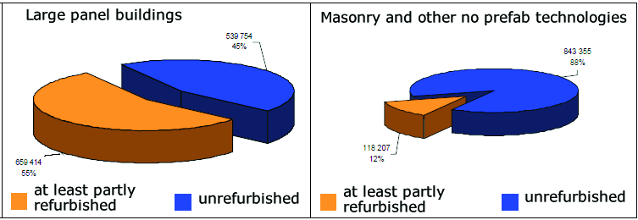
Source of data: PANELSCAN 2009

Table 10: Percentage of thermally refurbished envelope areas
 | Large panel buildings  (precast concrete) |  | Masonry buildings
 | SFH+TH | MFH+AB | SFH+TH | MFH+AB
Number of dwellings (1000) | neglected | 1199,20 | 1632,1 | 961,60
Heated area related  (1000 m2) | neglected | 72048 | 157824 | 57773
Windows replacement or renovation | unknown | 34 % | unknown | 12%
External thermal insulation of the fasade | unknown | 32 % | unknown | 12%
Roof renovation | unknown | 28 % | unknown | 12%
Source of data: PanelScan 2009

Table 11: Average insulation thicknesses (eq EPS 70F) added to the refurbished elements and
U values of new windows
 | 1998 | 2008 | 2012  (estimation) | Remarks
walls | 50-60 mm | 85 mm | 100 mm | [1]
windows U values (W/m2.K) | 2,3-2,8 | 1,4-1,8 | 0,8-1,2 | [2]
roofs / upper floor ceilings | 120 mm | 160 mm | 220 mm | [2]
basement / cellar ceiling | 50 mm | 75 mm | 100 mm | [2]
[1] the source of data: Sdružení EPS ČR
[2] mainly based on estimations and standard requirements

Energy Balance Method

The energy balance model was created on basis of the statistical data collected mainly from the National census 2001 and from the Microcensus ENERGO 2004. The delivered energy and the energy demand for space heating of the considered six groups of buildings was calculated using national calculation method.

The methodology is based on the delivered energy needed under standard indoor and outdoor conditions. Energy consumption of the building is defined as amount of energy needed for the fulfilment of various demands related to the standard use of the building. The national calculation method is based on the simplified dynamic calculation. The energy demand was calculated from monthly values.

The national calculation software tool (NCT) was used for this purpose.The simplified process of calculation was divided into two steps:

- calculation of energy demand of the synthetic buildings
- calculation of of the energy required by the energy systems (heating and DHW systems). needed to produce the necessary heat and domestic hot water. The energy demand was calculated for a standard use of the buildings.

Following simplificatory assumptions were made in order to process the calculation:
- each synthetic building consisting of one conditioned zone only
- one climatic zone
- natural ventilation rate fixed at 0,5 h⁻¹
- internal temperature in the buildings considered as constant value
- average efficiency values used for heat generators, storage and distribution and heat emission in each group
- average annual consumption of DHW 23 m³/occupant
- no air conditioning and mechanical ventilation considered as these systems are marginal for the housing sector
- partial reduction factors were used to estimate the reduced heat demand due to partial thermal refurbishments of the buildings

Energy Balance of the Residential Building Stock

The statistical tables presented above were used to define the average gross floor areas of synthetic buildings. The mean values of areas of the windows, floors, roofs/ceilings and exterior walls were estimated according to the expert knowledge of the geometrical properties of real buildings and their frequency. The U values were taken from the Czech standards valid in the period of building construction. The refurbishments play important role only in the groups APT2 and APT3.
The total reduced energy consumption is estimated to 20%. in the whole group APT2 and 10-15% in the whole group APT3. These estimations are quite modest with special regards to the fact that relatively many refurbishment projects did not meet the expectations for multiple reasons.
Most of the buildings in the groups APT2 and APT3 are heated with centralized heating thus it was possible to estimate the efficiency ratios. The heating systems in the groups of single family houses are variable: Table 8 and Table 9 were useful as a basis for the calculation of primary energy and the CO2 emissions. The overview of used values and results is presented in the Table 12.

Table 12: Overview of values used for 6 groups of buildings and the calculation results
 | SFH1 | SFH2 | SFH3 | APT1 | APT2 | APT3
 | -1945 | 1946-1980 | 1981-2001 | -1945 | 1946-1980 | 1981-2001
area (m²) | 68,7 | 86,6 | 109,7 | 352,0 | 684,0 | 842,9
A_{wall} (m²) | 85,4 | 93,1 | 110,6 | 290,0 | 520,8 | 574,3
A_{window} (m²) | 9,80 | 13,30 | 18,29 | 70 | 152 | 200,7
A_{floor} (m²) | 41,7 | 50,56 | 57,93 | 188 | 171 | 183,1
A_{roof/ceil} (m²) | 50,8 | 63,2 | 72,42 | 216 | 196,65 | 210,6
U_{wall} (W/m².K) | 1,4 | 1,1 | 0,6 | 1,4 | 1,1 | 0,6
U_{window} (W/m².K) | 2,35 | 2,35 | 1,7 | 2,35 | 2,35 | 1,7
U_{floor} (W/m².K) | 0,94 | 0,68 | 0,68 | 0,94 | 0,68 | 0,68
U_{roof/ceil} (W/m².K) | 0,9 | 0,51 | 0,31 | 0,9 | 0,51 | 0,31
Conditionned volume (m³) | 192,36 | 242,48 | 307,22 | 1353,6 | 1983,6 | 2389
Delivered energy (kWh/m².year) | 328 | 261 | 146,5 | 304 | 215 | 164
Energy demand (kWh/m².year) | 262 | 208 | 131 | 217 | 154 | 122
Number of dwellings | 593 141 | 629 643 | 389 722 | 370 807 | 1 231 234 | 542 288
Total m² | 36382845 | 48797333 | 37674426 | 20082907 | 70648207 | 33122951
CO2 (T) | 5490512 | 5876381 | 2613823 | 2936109 | 6542421 | 2600015
Total delivered energy (GWh) | 11934 | 12736 | 5519 | 6105 | 15189 | 5432
TOTAL (PJ) | 204,73

Comparison to National Statistical Data of the Residential Building Stock

There is no national methodology available to calculate the national balance however the calculated results can be compared with PORSENNA report (2007). The most important boundary conditions of PORSENNA study are presented in the Table 13. The value E_{a} means energy delivered to the building (consumed energy). It is obvious that the calculated delivered energy is quite close to PORSENNA estimation.

The total calculated energy used for heating, DHW and lighting of the housing stock is 204,7 PJ.
PORSENNA estimation for the year 2007 is 174 PJ for the heating and 25 PJ for the DHW.
Another source of data that can be compared with the calculated results is shown in Tab 8. The table published by the Ministry of Industry and Trade in 2007 shows total energy consumption for the heating and DHW which is 214,75 PJ. The standard deviation of calculated result is ±2,5%.

The CO2 emissions were calculated by using general emission factors according to the Czech
Decree No. 425/2004. The total CO₂ emissions are 26,059,000 T. The CO₂ emissions calculated
according to the Table 9 are 23,586,500 T. The standard deviation of calculated result is ± 5%.

Table 13: PORSENNA boundary conditions of the housing stock
Construction period | Until 1979 | 1979-1985 | 1985-1992 | 1992-2002 | Since 2002 | LEH | PH
Completed dwellings | 2927461 | 386199 | 324563 | 216746 | 122488 | None | None
SFH | 1649756 | 172601 | 138748 | 112823 | 62649 | None | None
APT | 1277705 | 213598 | 191605 | 169235 | 79735 | None | None
E_{a} average (kWh/m2/year) | 280 | 220 | 195 | 170 | 120 | 50 | 15
E_{a} SFH (kWh/m2/year) | 300 | 200 | 180 | 150 | 130 | 50 | 15
E_{a} MFH+AB (kWh/m2/year) | 260 | 230 | 200 | 180 | 110 | 50 | 15
U_{wall} | 1,45-1,37 | 1,39-1,19 | 0,89-0,79 | 0,5 | 0,38-0,30 | 0,15 | 0,10-0,15
U_{roof} | 0,89-0,83 | 0,93-0,79 | 0,51-0,43 | 0,41-0,36 | 0,3-0,24 | 0,12 | 0,10-0,12
U_{ceiling/cellar/} | 0,47-0,43 | 0,47-0,43 | 0,47-0,43 | 0,34 | 0,3-0,24 | 0,12 | 0,10-0,12
U_{window} | 2,9 | 2,9 | 2,9 | 1,8 | 1,7 | 1,20-0,80 | 0,80

Calculation of Energy Saving Potentials
According to the recently performed study “PANELSCAN” still over 45% of large panel buildings and approximately 90% of masonry and other buildings shall be refurbished. The energy saving potential is relatively high. It was estimated by experts that by achieving U values prescribed by the latest version of the Czech standard CSN 730540 following amount of energy can be saved:

20% of energy in average can be saved by applying ETICS (External thermal insulation composite systems) to the exterior walls.
10% of energy in average can be saved by roof insulation
25% of energy in average can be saved by windows replacement
heating control systems would bring savings ranging approximately between 5 and 15%
The losses can be reduced up to 50% by insulating properly the pipes.

The above mentioned percentage figures were considered in the calculation model and distributed over the categories of buildings. The results are shown in the Table 14.

The calculated overall energy saving potential is 83,6 PJ. The calculated CO₂ reduction potential is 10,6 mil tons.

The biggest energy saving potential can be obviously found in the group of the oldest single family houses. It is representing nearly one third of the total housing stock energy saving potential. However it is important to mention that this is the worst documented part of the housing stock especially as for the recent renovations and the quality of works done. Another interesting group is APT2 which consists mainly of large panel buildings with rather poor quality of insulation and high degree of cold bridges. These standardized buildings offer good opportunities for optimized and solutions that can be used repeatedly.

Table 14: Energy saving and CO2 saving potential in the housing sector
 | SFH1 | SFH2 | SFH3 | APT1 | APT2 | APT3
Number of  dwellings | 593 141 | 629 643 | 389 722 | 370 807 | 1 231 234 | 542 288
Total m² | 36382845 | 48797333 | 37674426 | 20082907 | 70648207 | 33122951
Total delivered energy (GWh) | 11934 | 12736 | 5519 | 6105 | 15189 | 5432
CO2 (T) | 5490512 | 5876381 | 2613823 | 2936109 | 6542421 | 2600015
Energy saving potential (GWh) | 7757 | 4840 | 1105 | 3236 | 5316 | 978
CO₂ saving  potential (T) | 3568787 | 2233172 | 523333 | 1556306 | 2289783 | 468118

Perspectives and Conclusions

The selected building typology approach with above described calculation models has contributed to energy balance analysis of the Czech building stock and enabled to estimate the energy saving potential and the potential for reduction of CO₂ emissions. The calculated energy balance and energy saving potential are in quite good correlation with recently conducted study from PORSENNA It has been proved that a definition of six groups of average synthetic buildings with realistic determination of decisive parameters for energy behaviour is sufficient to estimate with reasonable degree of precision the energy consumption of the Czech building stock. The perspectives are mainly seen in the application of the same approach for fast and reliable analysis of different scenarios looked at the housing stock.

Table 15: Sources / References Czech Republic
Reference shortcut | Short description | Reference
VDB-Public database | Public Database of the Czech Statistical Office (CZSO) mainly using data from National census in 2001 | Veřejná databáze Českého statistického úřadu (ČSÚ) obsahující především údaje ze sčítání domu a bytů v roce 2001
PORSENNA - Report 2010 | Report from PORSENNA on the impact of additional thermal insulation of the buildings on the use of coal and gas. | Studie o dopadech zateplování budov na spotřebu uhlí a zemního plynu v České republice
PANELSCAN – Report 2009 | Report from CERPAD on the technical conditions of the Czech housing stock | Studie Centra regenerace panelových domů o stavu bytových domů v ČR – PanelSCAN 2009
Report 2011 | Technical University Ostrava 2011 | Studie stavu teplárenství-VŠB TU Ostrava 2011
TABULA Scientific Report CZ | National scientific TABULA report 2012 | Národní odborná zpráva z projektu TABULA 2012

Denmark
(by TABULA partner SBi / Denmark)

Building Typology Approach

The energy balance of the Danish residence buildings was calculated using synthetic average buildings, SyAv. These SyAv buildings were composed within each building period and building type (SFH, TH, AB). References to the buildings are shown in the table below.

Table 16: TABULA model
Building period | Single-family houses | Terraced houses | Block of flats
Before 1850 | SFH.AvSy.01 | RH.AvSy.01 | AB.AvSy.01
1851-1930 | SFH.AvSy.02 | RH.AvSy.02 | AB.AvSy.02
1931-1950 | SFH.AvSy.03 | RH.AvSy.03 | AB.AvSy.03
1951-1960 | SFH.AvSy.04 | RH.AvSy.04 | AB.AvSy.04
1961-1972 | SFH.AvSy.05 | RH.AvSy.05 | AB.AvSy.05
1973-1978 | SFH.AvSy.06 | RH.AvSy.06 | AB.AvSy.06
1979-1998 | SFH.AvSy.07 | RH.AvSy.07 | AB.AvSy.07
1999-2006 | SFH.AvSy.08 | RH.AvSy.08 | AB.AvSy.08
After 2007 | SFH.AvSy.09 | RH.AvSy.09 | AB.AvSy.09

Available Data

In Denmark the two primary data sources of building data are:

- The Danish building stock register (BBR)
- The building Energy Performance Certification (EMO) database

The building stock register contains general information of all Danish buildings. Relevant for this project is mainly data of heated floor area and information of the heating installation type.

In 2010 the Energy Performance Certification database covered approx. 10% of the single-family houses, 14% of terraced houses and 13% of block of flats.

Both databases are continually updated. The BBR register is updated whenever an existing building is extended or a new building is finalised. The building energy performance experts report their certificate data directly into the EMO database, so at any given time the database contains information from all new and existing certificates. Data for this project were extracted in April 2010.

Data of building modernisation is not included in any of the databases as these only represent the latest data for a property or building. Furthermore, in the future the EMO database will contain data for buildings that have been certified more than once. Currently the validity period of Danish EPC certificates is settled to 5 years, so it has not become a problem yet.

Energy Balance Method

In Denmark a national Energy Balance method already exists. The model has been used in several studies of the energy saving potentials [SBi,1]. The knowledge of the different input data has been used to make a similar Energy Balance calculation using the TABULA approach.

The results were calculated using the reference EU boundary conditions (SUH.EU and MUH.EU) and an adjusted boundary for Danish conditions similar to the Danish Energy Balance Method.

The synthetically average buildings
The SyAv buildings were composed by average U-values extracted from the EMO database. U-values of ceilings, walls, floors and windows were calculated within each building period and building type using the equation:
U_{avg} = Σ A_{i} * U_{i} / A_{tot}

Where “i” is the reference to the specific construction

The corresponding areas of the building envelope constructions were achieved from the Danish energy balance method, which uses the same approach for the average U-values as described above.

Energy Balance of the Residential Building Stock

The results of the Energy balance calculation using the TABULA approach are presented below.

Net energy for heating (space heating)
The calculation result of the energy balance is very dependent on the assumed boundary conditions. The calculation of the space heating demand and the national statistic of the net heating energy consumption were used to calibrate the boundary conditions.
Comparisons of the national boundary conditions with the EU standard conditions are shown below for single-unit houses (SUH) and multi-family houses (MUH):
Table 17: Boundary conditions
 | Single unit houses (SUH) |  |  |  | Multi-unit houses (MUH)
 | EU.SUH | DK.SUH_19 | DK.SUH | DK.SUH_21 | EU.MUH | DK.MUH
internal temperature | 20 | 19 | 20 | 21 | 20 | 21
reduction factor, considering the effect of night setback and unheated space, value at h_tr = 1 W/(m²K), | 0.9 | 0.9 | 0.9 | 0.9 | 0.95 | 0.95
reduction factor, considering the effect of night setback and unheated space, value at h_tr = 4 W/(m²K), | 0.8 | 0.8 | 0.8 | 0.8 | 0.85 | 0.85
average air change rate, due to use of the building | 0.4 | 0.45 | 0.45 | 0.35 | 0.4 | 0.7/0.6/0.5
room height (based on internal dimensions) | 2.5 | 2.8 | 2.8 | 2.8 | 2.5 | 2.8
average internal heat sources per m² reference area | 3 | 5 | 5 | 5 | 3 | 5
reduction factor external shading, horizontal orientation | 0.8 | 0.8 | 0.8 | 0.8 | 0.8 | 0.8
reduction factor external shading, vertical orientations | 0.6 | 0.6 | 0.6 | 0.6 | 0.6 | 0.6
frame area fraction of window | 0.3 | 0.3 | 0.3 | 0.3 | 0.3 | 0.3
reduction factor, considering radiation non-perpendicular to the glazing | 0.9 | 0.9 | 0.9 | 0.9 | 0.9 | 0.9
internal heat capacity per m² reference area | 45 | 100 | 100 | 100 | 45 | 100
net energy need domestic hot water | 10 | 15 | 15 | 15 | 15 | 18

Results from space heating demand calculation
The results using the Danish boundary conditions are shown below. Energy consumption for hot water is not included in the presented results of energy demands for space heating.

Table 18 Space heating demand
[kWh/m²] | Single-family houses | Terrace houses | Apartment blocks
Building period | DK.SUH | DK.SUH | DK.MUH
Before 1850 | 199,6 | 198,6 | 198,4
1851-1930 | 204,9 | 215,8 | 209,8
1931-1950 | 214,1 | 219,2 | 209,4
1951-1960 | 191,6 | 192,4 | 168,6
1961-1972 | 160,2 | 155,6 | 152,1
1973-1978 | 141,7 | 133,5 | 146,9
1979-1998 | 124,2 | 118,0 | 143,9
1999-2006 | 82,0 | 82,2 | 98,3
After 2007 | 69,9 | 69,1 | 82,1

The difference between the EU and DK boundary condition was found to be approx.10 kWh/m² for the single-family and terrace houses. For the apartment block the DK boundary condition increases the net energy consumption mainly due to the higher assumed room temperature.

Energy demand for heating and hot water (Energy carriers)
Results from the TABULA approach are only presented for boundary conditions DK.SUH and DK.MUH.

Table 19: Energy Carriers [kWh/m²]
 | Period | Building type | SFH  DK.SUH | TH  DK.SUH | AB  DK.MUH
1 | Before 1850 | Total
 |  | District Heating | 213 | 212 | 201
 |  | Gas boiler | 228 | 227 | 216
 |  | Oil Boiler | 237 | 235 | 216
 |  | Electricity | 197 | 196 | 189
 |  | Heat pumps | 76 | 76 | 57
2 | 1851-1930
 |  | District Heating | 219 | 220 | 215
 |  | Gas boiler | 234 | 235 | 231
 |  | Oil Boiler | 242 | 244 | 231
 |  | Electricity | 202 | 203 | 202
 |  | Heat pumps | 78 | 81 | 60
3 | 1931-1950
 |  | District Heating | 245 | 240 | 215
 |  | Gas boiler | 262 | 256 | 231
 |  | Oil Boiler | 270 | 265 | 231
 |  | Electricity | 227 | 222 | 202
 |  | Heat pumps | 81 | 83 | 60
4 | 1951-1960
 |  | District Heating | 247 | 236 | 197
 |  | Gas boiler | 265 | 252 | 211
 |  | Oil Boiler | 273 | 261 | 211
 |  | Electricity | 229 | 218 | 185
 |  | Heat pumps | 81 | 81 | 56
5 | 1961-1972
 |  | District Heating | 202 | 189 | 179
 |  | Gas boiler | 216 | 202 | 193
 |  | Oil Boiler | 224 | 210 | 193
 |  | Electricity | 186 | 174 | 168
 |  | Heat pumps | 73 | 65 | 52
6 | 1973-1978 | Total
 |  | District Heating | 174 | 153 | 164
 |  | Gas boiler | 186 | 163 | 176
 |  | Oil Boiler | 194 | 171 | 176
 |  | Electricity | 160 | 140 | 154
 |  | Heat pumps | 62 | 59 | 50
7 | 1979-1998
 |  | District Heating | 141 | 118 | 153
 |  | Gas boiler | 150 | 126 | 164
 |  | Oil Boiler | 159 | 134 | 164
 |  | Electricity | 129 | 108 | 144
 |  | Heat pumps | 52 | 51 | 48
8 | 1999-2006
 |  | District Heating | 94 | 94 | 104
 |  | Gas boiler | 95 | 96 | 112
 |  | Oil Boiler | 95 | 96 | 112
 |  | Electricity | 87 | 88 | 69
 |  | Heat pumps | 46 | 40 | 38
9 | 2007-2011
 |  | District Heating | 48 | 48 | 57
 |  | Gas boiler | 49 | 49 | 57
 |  | Oil Boiler | 49 | 49 | 57
 |  | Electricity | 74 | 75 | 36
 |  | Heat pumps | 34 | 33 | 34

Comparison to National Statistical Data of the Residential Building Stock

The statistic of the energy consumptions of residential buildings is made every year by the Danish Energy Agency. The statistic includes both the net energy demands and the energy carriers.

In comparison of national statistic and the TABULA approach, the calculated total energy consumption for heating was climate adjusted according to the number of degree-days in each of the two methods.

Table 20: Number of heating degree days
Danish Statistic 2010 | 3.221
TABULA Approach – DK | 3.118
Difference | 3.3%

To calculate the total energy consumption the unit consumption in kWh/m² (internal floor area) was converted to external area using a factor 1.18 (according to the TABULA Excel sheet).

For calculations according to the TABULA approach boundary conditions DK.SUH and DK.MUH described above have been used. The results are shown below.

Table 21: Net Energy Demand for heating and hot water
[PJ] | Single-family houses  and Terraced houses | Block of flats
Danish Statistic 2010 | 109,5 | 43,4
TABULA Approach – DK | 113,3 | 44,5
Diff. to TABULA Approach - DK | 3,4% | 2,4%

Table 22: Energy carriers
[PJ] | Boundary | Single-family houses  and Terraced houses | Block of flats
Danish Statistic 2010 | DK.SUH / DK.MUH | 132.012 | 46.207
TABULA Approach – DK | - | 119.515 | 47.387
Diff. to TABULA Approach - DK | - | -9.5% | -2.6%

Calculation of Energy Saving Potentials
The technical energy-saving potential is calculated not taking into account different barriers as economy, constructive limitations or architecture.

The different measures follow the recommendations given by the Danish knowledge centre of Energy savings in Buildings.

Recommendations for energy saving measures are:

Table 23: Recommendations for energy saving measures
 | Standard | Ambitious
Ceiling | 300 mm | 400 mm
Wall (outside) | >100 mm | >200 mm
Wall (inside) | 50 mm | 50 mm
Cavity wall | Filled | Filled
Floor on soil | 250 mm | 250 mm
Floor above cellar | >100 mm | >200 mm
Windows | with double energy glazing | with triple energy glazing

Energy saving potential is calculated for the two scenarios: Standard and Ambitious.
The results are presented in the table below.

Table 24: Net Energy Demand for heating and hot water
[PJ] | Single-family houses  and Terrace houses | Apartment blocks
Reference | 113,3 | 43.7
Standard measures | 60.8 | 24.5
Ambitious measures | 57.1 | 22.4

The total theoretical potential of energy savings are approx. 72 and 78 PJ for the standard and the ambitious measures, respectively. The corresponding CO2 reduction is 3.1 and 3.4 million tons CO2 respectively assuming the current mix of energy sources.
The energy-saving potential is a theoretical figure and not fully achievable for the whole building stock due to previously mentioned barriers of economy, technical and architectural limitations.

Perspectives and Conclusions

The energy-saving potential is high even considering years of campaigns promoting energy saving, the energy-saving subsidies given and energy saving audits, and the fact that in Denmark the energy consumption has not increased since 1980. The general perception is that much has been achieved and generally house owners claim that they are conscious of their energy consumption, but that further investment in energy-saving measures cannot pay for itself.

Table 25: Sources / References Denmark
Reference shortcut | Short description | Reference
[SBi,1] | The energy consumption of the Danish buildings in 2050 | Danske bygningers energibehov i 2050

Germany
(by TABULA partner : IWU / Germany)

Building Typology Approach

The analysis of the German building stock of the year 2009 was carried out with a set of six synthetical average buildings which consider two building size classes(SFH: single family houses with one or two dwellings / MFH: multi family houses with three or more dwellings) and three construction year classes (I – III) according to different levels of energy saving regulations in Germany. The first age band includes the buildings which were constructed until 1978, that means before the first German ordinance on thermal protection. The two later periods (1979 – 1994 and 1995 – 2009) were chosen according to further development of this ordinance (more than one within each period) including the introduction of the more far-reaching energy saving ordinance in 2002.

Table 1 gives an overview of some basic data about the frequency of the six building types in the German building stock:

Table 26: Frequencies of the building types SFH I,II,III and MFH I,II,III
in the German building stock
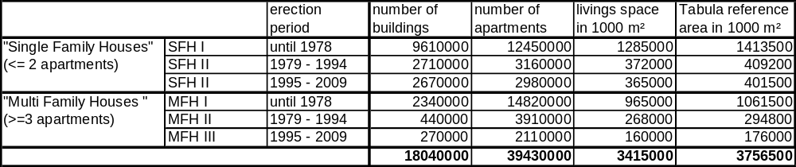

Available Data

More detailed information of the building types is given in the following tables. Table 27 shows the basic data of the thermal envelope, that means the areas and the U-values of the different elements wall, roof / upper floor ceiling, ground floor / cellar ceiling and windows.

Table 27: Basic data of the six synthetical average building types SFH I,II,III / MFH I,II,III
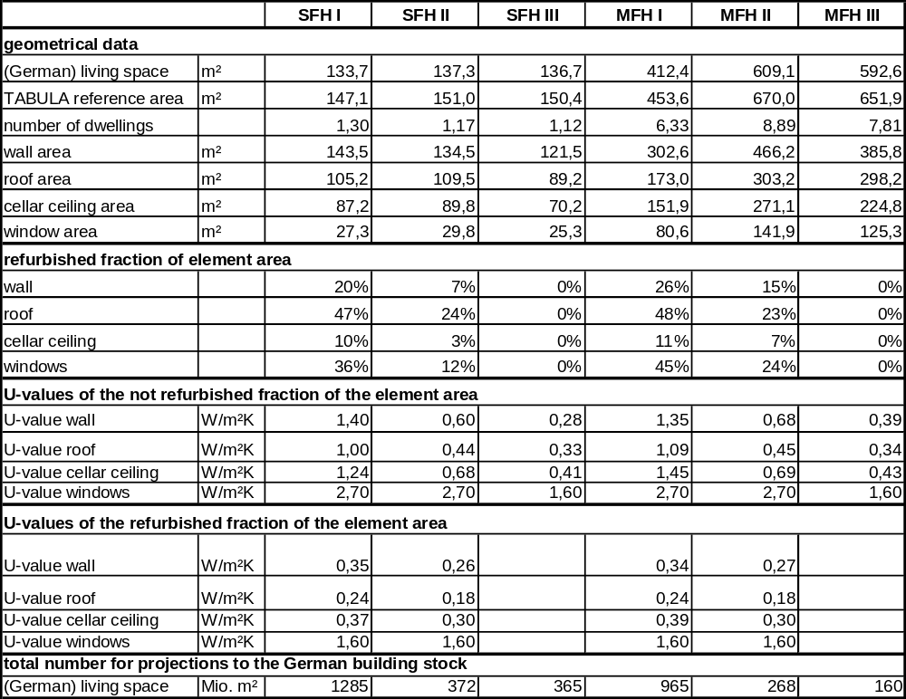

Three main data sources were used to define the synthetical building types:
- Mean values of the element areas (e.g. wall area related to living space) were derived from an energy certificate data base of the German Energy Agency (dena) which included data from 487 energy certifcates which were issued according to dena’s quality assurance scheme.
- The U-values of the not refurbished buildings were calculated as mean values from the respective generic types of the TABULA German building typology (considering the different frequencies of generic building types which belong to the same synthetical type SFH I – MFH III, respectively).
- The U-values of the refurbished element areas and the percentage of refurbished elements were calculated by the data of a representative survey of the German building stock (“Datenbasis Gebäudebestand” [IWU 2010]) which includes the data of more than 7.300 questionnaires which were filled in by owners of residential buildings. In this survey a comprehensive data set was collected about the energy saving measures (insulation measures, heat supply systems, solar systems) which were carried out – at the time of building construction or during later building modernisation.

The data of the representative survey were also used for the analysis of the heat supply structure of the building types. In Table Table 28 a rough overview is given, more detailed data were considered concerning the insulation of heat distribution systems, the type of heat generator (e.g. boilers), the application of solar systems and ventilation systems, for example.

Table 28: Heat supply structure of the building types SFH I – MFH III (overview)
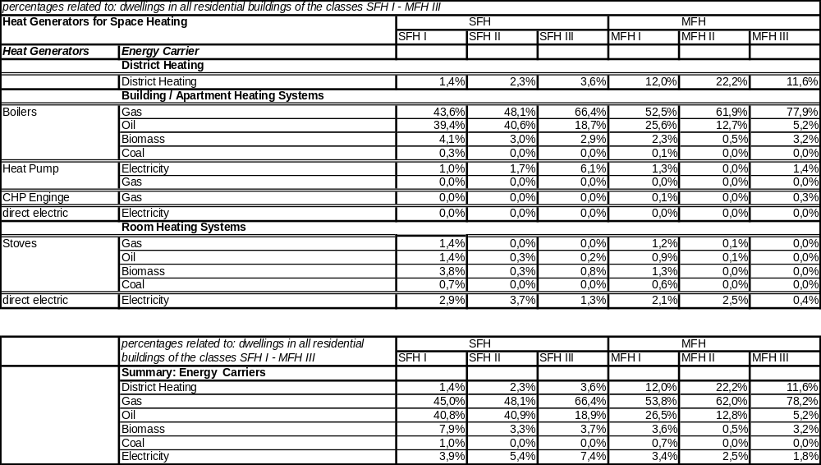

Energy Balance Method

In general, the energy balance model was developed on basis of the available statistical input data. The energy demand for space heating of the considered six building types was calculated according to a seasonal energy balance approach which is similar to the approach of the TABULA webtool or to other seasonal methods (e.g. [LEG]). Some additional assumptions had to be made here, e. g. the internal temperature of the buildings was not considered to be a constant value (e. g. 19,5 ºC) as in usual seasonal balance methods, but according to practice experience [IWU 2003] it was considered that average room temperatures in non-modernised buildings are on average considerably lower than in those buildings which were already insulated (here assumed: temperature difference of about 3 K between buildings with a very low and a very good insulation level).
The efficiency values of the different heat supply systems were set in the range of typical values which are used for energy balance calculations in Germany (close to the German TABULA heating system typology). In general, the energy balance model was developed on basis of the applied statistical input data. So some simplifications were made (e.g. different values of the efficiency of boilers were considered for constant temperature, low temperature and condensing boilers but within those subsets different installation years were not considered separately). Additional assumptions were sometimes necessary: For example it had to be considered that in a considerable part of the German building stock wood fired stoves are applied as additional heating systems, but there is no information available about their contribution to space heating. Here it was assumed that they contribute with 15 % to the heat demand for space heating.

Energy Balance of the Residential Building Stock

The following tables show the results of the energy balance calculations for the German building stock 2009. The energy consumption values are shown in units of billion (10⁹) kilowatt-hours (kWh). The heat consumption and the final energy consumption are depicted separately for the six building categories. The final energy of fuels (gas, oil, coal biomass) is related to the net calorific value to make possible a comparison with national statistics which usually use the net calorific value.

Table 29: Heat consumption of the German residential building stock (2009) for space heating and hot water (model calculations)
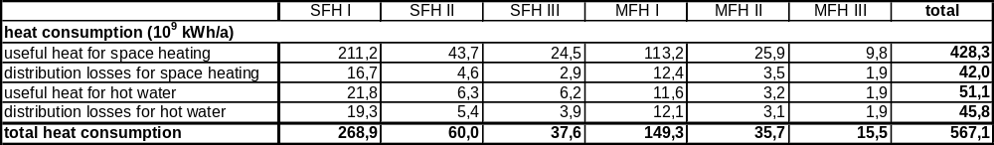

Table 30: Final energy consumption of the German residential building stock (2009) for space heating and hot water (model calculations, in case of fuels: net calorific value)
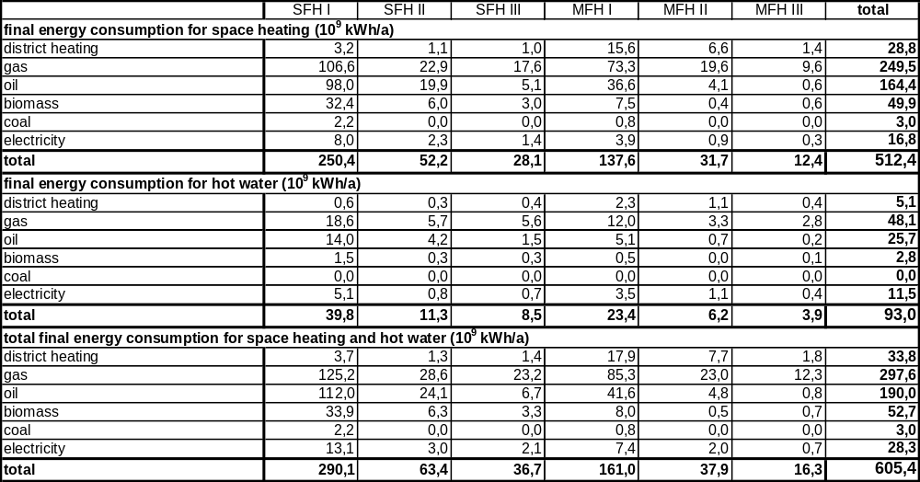

The value of electricity consumption includes electric energy used for heat generation (directly or by electric heat pumps) as well as auxiliary energy of the heat supply system (e. g. for pumps of distribution systems, device control, ventilation systems).

The following table shows the primary energy consumption and the CO2 emissions. The later are defined as direct emissions in the residential buildings or emissions in power plants and district heating plants which are related to the district heat or electricity delivered to residential buildings to cover heat supply. CO₂ equivalent values of other greenhouse gases are not considered.

Table 31: Primary energy consumption (left) and CO₂ emissions (right) of the German residential building stock (2009) for space heating and hot water (model calculations)
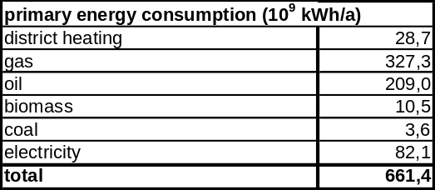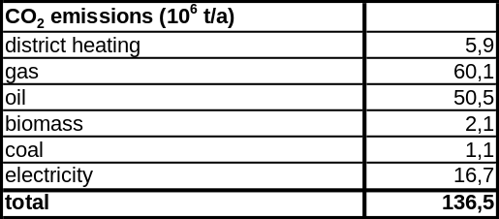

Comparison to National Statistical Data of the Residential Building Stock

In Table Table 32 the model results are compared with the national energy balance (mean values of actual consumption of households). Because of the deviations of annual climate parameters a direct comparision with the consumption values of the single year 2009 did not appear appropriate, instead mean values of the period 2005 – 2009 are given. The source of the values is a publication of the German federal ministry of economy [BMWi 2011] which is based on the results of the “Arbeitsgruppe Energiebilanzen” (AGEB,German energy balance working group) .
Table 32: Comparison of model results with national energy statistics
(mean values 2005 – 2009, in case of fuels: net calorific value)
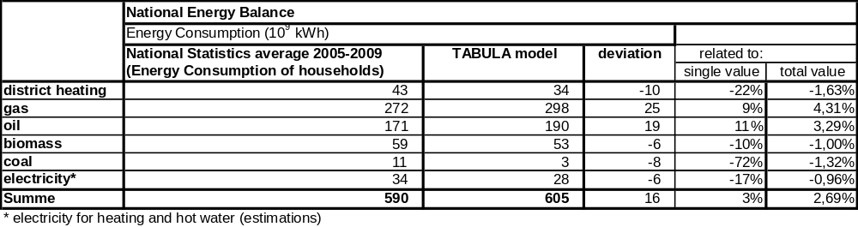
The table shows that the model calculations fit satisfactory with the values of the national energy balance. The deviations of the most important energy carriers gas and oil are about 10 %, some other deviations are highter (e.g. 22 % in the case of district heating). Related to the total final energy consumption of 590 billion kWh the deviations are all below 5 %. The deviation of the total value is around 2,7 %.
It has to be considered that – besides the questions of annual climate and time development since 2005 – the quoted national statistics are to some extent uncertain because the delivered values can not be directly measured: Analyses have been done by AGEB for example to break down total values of energy consumption (e. g. of gas consumption) to the different consumption sectors (here: households). The value of electricity consumption which is here only related to space heating and hot water supply (and not including other household appliances) is especially uncertain. It was derived from a separate analysis by AGEB regarding the energy balance of the year 2008 [AGEB 2011].

Calculation of Energy Saving Potentials

Based on the described model an estimation of energy saving potentials in the German building stock for heating and hot water supply was carried out.
Two quality levels of energy saving measures were considered which are shown in Table 33.
Table 33: Assumed energy saving measures
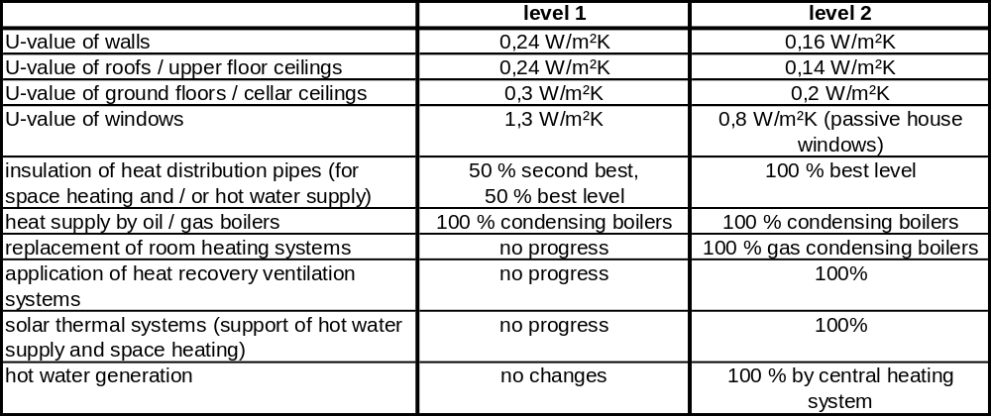

Table 34 shows the results of the model calculations:
Table 34: Calculated energy savings by applying the level 1 and level 2 measures to the current (2009) German residential building stock
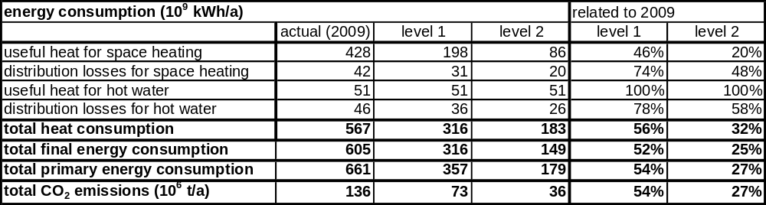

At level 1 the achieved primary energy consumption and CO₂ emission amount to about 55 % of the original value, that means that the reduction of energy consumption and emissions is around 45 %.
At level 2 the heat consumption is reduced to about a third of the original value. Together with the additional changes of the heat supply structure this results in values of primary energy and CO2 emissions which are at about 27 % of the original value. Thus more than 70 % of primary energy and CO2 emissions could be saved by applying the level 2 measures to the complete building stock.
This exemplary model analysis demonstrates the energy savings which could theoretically be achieved in the building stock if in the first place a consequent thermal protection of the buildings and a thus reduction of heat consumption could be achieved. Of course this is only a hypothetical calculation of technical energy saving potentials according to different levels of quality. These calculations can be seen as a first test application of the model. It is intended to give a rough impression of the magnitude of energy saving potentials which could be attained if there was a consequent reduction of the buildings’ heat demand, but the results are based on rough and simplified assumptions and thus can not be seen as a part of a realistic scenario.
In practice there are of course some obstacles in the building stock (for example but not only at historical monuments) which will not permit the general achieving of level 2 measures. In future scenario analysis realistic annual refurbishment rates will have to be considered as well as the influence of the new construction sector and demolition of buildings (of which the later does not play a major role in Germany until now). Besides, even more far-reaching changes in the energy supply structure, e.g. a more significant use or renewable energies should be taken into consideration.

Perspectives and Conclusions
The described model and the exemplary calculations demonstrate the application of the building typology concept to energy balance analysis of the German building stock. By defining a manageable number of six synthetical average buildings which reflect the current state of building modernisation and the current heat supply structure a satisfactory approximation of the energy consumption of the German building stock could be attained. Exemplary calculations of technical energy saving potentials were carried out to demonstrate first steps towards future applications of the model in the framework of scenario analysis.

Table 35: Sources / References Germany
Reference shortcut | Short description | Reference
[AGEB 2011] | Study of the national energy balance working group | Arbeitsgemeinschaft Energiebilanzen e. V., Anwendungsbilanzen für die Endenergiesektoren in Deutschland im Jahr 2008, Berlin, Februar 2011
[BMWi 2011] | National energy balance (published by German Minstry of economy) | Energiedaten – Zahlen und Fakten, Stand: 7.9.2010 (Excel- Tabelle), www.bmwi.de
[IWU 2003] | in this study a model for a typical user in residential buildings is defined, the models are based on analyses of several research studies | Loga, Tobias; Großklos, Marc; Knissel, Jens: Der Einfluss des Gebäudestandards und des Nutzerverhaltens auf die Heizkosten – Konsequenzen für die verbrauchsabhängige Abrechnung. Eine Untersuchung im Auftrag der Viterra Energy Services AG, Essen; IWU Darmstadt, Juli 2003
[IWU 2010] | Final report of the project „Datenbasis Gebäudebestand“ | N. Diefenbach et al., Datenbasis Gebäudebestand – Datenerhebung zur energetischen Qualität und zu den Modernisierungstrends im deutschen Wohngebäudebestand, Institut Wohnen und Umwelt, Darmstadt, Dezember 2010
[LEG] | calculation procedure for the energy balance of buildings and supply systems | Leitfaden Energiebewußte Gebäudeplanung; Hg.: Hessisches Ministerium für Umwelt, Energie, Jugend, Familie und Gesundheit; Wiesbaden 1995
[Typology Brochure 2011] | German Building Typology Brochure | Loga, Tobias; Diefenbach, Nikolaus; Born, Rolf: Deutsche Gebäudetypologie. Beispielhafte Maßnahmen zur Verbesserung der Energieeffizienz von typischen Wohngebäuden; IWU, Darmstadt 2011

Greece
(by TABULA partner NOA/Greece)

Building Typology Approach

The Hellenic typology consists of 24 building types, derived after a classification of the residential building stock in three time construction periods – age bands (prior to 1980, 1981-2000 and 2001-2010), two sizes (single family, multifamily) and four climatic zones defined according to the number of heating degree days (Zone A (601–1100), Zone B (1101–1600), Zone C (1601–2200) and Zone D (2201–2620)). The buildings included in the typology are real examples that can be considered as representative of the corresponding classes. However, due to peculiarities in their initial construction or refurbishment actions taken on their envelope and/or system installations over the years, they may not reflect the typical buildings of their class. Thus, the set of buildings included in the TABULA typology has to be elaborated before it is used in the building stock balance model.

The derivation of the national energy balance was based on “typical” buildings defined for each of the 24 typology classes. In order to define the characteristics of the “typical” buildings in all the building classes of the Hellenic typology, it would be necessary to have detailed statistical data regarding the construction and system installations in the building stock. Due to the lack of official national data in the required level of detail, it was decided that the “typical” buildings used in this study would have the same architectural features as the “real examples”. In collaboration with experts active in the field of building construction, who also participate in the TABULA National Advisory Group (NAG), a mapping of the residential building stock at its current status was attempted regarding the most common construction types as well as systems for space and domestic hot water (DHW) heating. As a result, the Building Elements and the System sub-typologies were created, containing all the different types of opaque (walls, roofs, floors) and transparent elements as well as the system installations found in the Hellenic residential buildings. Different percentages were assigned to the various types of elements and systems reflecting their frequency of occurrence in the different parts of the building stock depending on the building size, age band and climatic zone [1].

The thermal characteristics of the typical building envelope (U-values for opaque and transparent elements as well as g-values for transparent elements) were derived as weighted averages using the frequencies of occurrence for all the existing types defined in the building element typology for each different class. Similarly, the installed system characteristics (performance coefficients for heat generation and distribution systems) were derived as weighted averages using the frequencies of occurrence for all the system types defined in the system typology for each different class.

Available Data

In order to form a building stock model it is necessary to determine frequencies for each building type. The main data sources for the derivation of the statistical data required for this analysis include:
- The Hellenic Statistical Service
- Existing and on-going studies
- National standards and regulations providing information on building construction types and heat supply systems
- Empirical data for the Hellenic building stock
Table 36 outlines the data that could be retrieved from the above sources regarding the Hellenic residential building sector.

Table 36: Available frequencies regarding the Hellenic residential building stock
Frequency | Description of data  (availability: per building size, age band and climatic zone)
Building types of the national building stock | Number of buildings, floor area (m²)
Insulation level and window types | Number/and percentage of buildings with  - non-insulated walls/roofs  - partly insulated walls/roofs
Centralization of the heat supply (for space heating) | Percentages of buildings
Heat generation (for space heating) | Percentages related to number of buildings with central heating systems
Solar thermal systems | Percentages of apartments in SFH/MFH buildings
Air conditioning systems | Number of apartments in SFH/MFH buildings
Control of central heating systems | Number of buildings

However the level of detail of the above data is not sufficient for deriving the building stock model. Frequencies of buildings corresponding to the different element and system types are not available in sufficient detail, while information on their state of modernization (refurbishment action, year) is restricted to the insulation level (absent, partial or full). Moreover, heat generation systems are not reported in detail, neither for water nor for space heating, while no frequencies are available on heat distribution systems what so ever.

The gaps in the availability of frequencies are attributed to the absence of systematic collection of the data. Most of the statistical data on the residential building sector come from the latest Censuses carried out in 1990 [4] and 2000 [5]. These data include number and size of buildings as well as floor area per building age band and geographic region. Further analysis carried out in the framework of the national project “Evaluation of supporting policies for the advancement of the Ministry’s policies in relation to the abatement of CO₂ emissions in the residential and tertiary Sectors’, which was financially supported by the Hellenic Ministry for the Environment, Physical Planning and Public Works, Directorate Urban Planning & Housing - MEPPPW [2] and published in [3] resulted in frequency distributions of buildings according to their level of thermal insulation, the installed systems for heat generation and the presence of solar systems for hot water heating.

In the absence of sufficient official data for the derivation of the national energy balance model it was decided to use “typical buildings”, as mentioned in the previous section. The thermo-physical properties of the envelope, as well as the expenditure coefficients per “typical” building, were derived as weighted averages per building class. The weighting factors for each category were well educated guesses derived in collaboration with NAG experts active in the field of construction and are, at present, a realistic estimate of the evolution of the construction and renovation trends over the years. Table 37 summarizes the resulting “typical” values of the thermal transmission coefficient for the main components of the building envelope for each of the 24 building classes of the Hellenic residential building typology.
Table 37: “Typical” values (weighted averages) of the thermal transmission coefficient (kWh/m²K) for the main components of the building envelope
 | Single Family Houses (SFH) |  |  | Multi Family Houses (MFH)
 | -1980 | 1980-2000 | 2000- | -1980 | 1980-2000 | 2000-2001
Climatic Zone A
Wall | 2.36 | 1.28 | 1.01 | 2.13 | 1.11 | 0.81
Roof | 3.12 | 1.68 | 0.91 | 2.96 | 1.33 | 0.72
Floor | 3.07 | 2.95 | 2.94 | 3.07 | 2.21 | 2.08
Window -U | 4.89 | 4.82 | 3.33 | 5.14 | 4.88 | 4.40
- g | 0.60 | 0.57 | 0.54 | 0.62 | 0.58 | 0.55
Climatic Zone B
Wall | 2.02 | 0.96 | 0.86 | 2.06 | 1.09 | 0.75
Roof | 2.72 | 1.09 | 0.70 | 2.85 | 1.28 | 0.62
Floor | 2.60 | 2.02 | 1.93 | 2.13 | 1.52 | 1.00
Window -U | 4.71 | 4.51 | 3.33 | 4.99 | 4.25 | 3.55
- g | 0.59 | 0.56 | 0.54 | 0.61 | 0.51 | 0.55
Climatic Zone C
Wall | 2.02 | 0.96 | 0.86 | 2.06 | 1.09 | 0.75
Roof | 2.72 | 1.09 | 0.70 | 2.85 | 1.28 | 0.62
Floor | 2.28 | 1.01 | 0.79 | 2.68 | 1.21 | 0.74
Window -U | 4.71 | 4.51 | 3.33 | 4.99 | 4.25 | 3.55
- g | 0.59 | 0.56 | 0.54 | 0.61 | 0.51 | 0.55
Climatic Zone D
Wall | 2.61 | 1.02 | 0.86 | 2.00 | 1.02 | 0.75
Roof | 3.06 | 1.15 | 0.71 | 2.76 | 1.20 | 0.62
Floor | 2.47 | 1.00 | 0.79 | 2.10 | 1.06 | 0.66
Window -U | 4.63 | 4.33 | 3.33 | 4.92 | 4.52 | 3.53
- g | 0.60 | 0.56 | 0.54 | 0.61 | 0.56 | 0.55

Similarly, Table 38 summarizes the “typical” expenditure coefficients (based on the Higher Calorific Value) for the systems installed in the 24 buildings of the Hellenic typology, based on their size and time construction period. In this case, no distinction is made for different climatic zones, since they are applicable for the entire country.

Table 38: “Typical” values (weighted averages) of the expenditure coefficient (higher calorific value) for the space and water heating systems
 | Single Family Houses (SFH) |  |  | Multi Family Houses (MFH)
Energy carrier | -1980 | 1980-2000 | 2000-2010 | -1980 | 1980-2000 | 2000-2010
Space Heating Systems
Fuel | 1.38 | 1.30 | 1.22 | 1.37 | 1.25 | 1.20
Electricity | 0.97 | 0.64 | 0.29 | 0.94 | 0.71 | 0.28
Water Heating Systems -
Fuel | 1.33 | 1.26 | 1.31 | 1.35 | 1.26 | 1.31
Electricity | 1.05 | 1.03 | 1.03 | 1.05 | 1.03 | 1.03

Finally, Table 39 summarizes the “typical” performance coefficients for the distribution system. In this case, no distinction is made for different building sizes or energy end use, so they are applicable for the entire building stock based on the time construction period.

Table 39: “Typical” values (weighted averages) of the performance coefficient for the distribution systems of single and multi family houses, according to the insulation level of the system.
Level of insulation | Single / Multi Family Houses
Level of insulation | - 1980 | 1980-2000 | 2000-2010
Pipelines non/partly insulated | 0.89 | 0.93 | 0.93
Pipelines well insulated | 0.97 | 0.97 | 0.97

Further assumptions that were made for some parameters affecting the performance of the “typical” buildings are summarized in Table 40.

Table 40: Parameters affecting the energy performance of the “typical” buildings
Infiltration (m³/hm²_{window})
Single glazing, wooden frame | 13.45
Double glazing, wooden frame | 11.15
Single glazing, aluminium/PVC frame | 8.05
Double glazing, aluminium/PVC frame | 6.05
Thermal bridges
Prior to 1980 | No
After 1980 | Yes, medium (U_{opaque elements}+0.1 W/m²K)
Space heating system controls
Prior to 1980 | no controls
After 1980 | Zone thermostats,  Indoor-outdoor temperature compensation
Performance of heat emission components – space heating
heating medium: high temperature water  (ie: radiators, convectors) | 0.87
heating medium: low temperature water  (ie: fan coils, underfloor systems) | 0.91
Performance of heat emission components – DHW heating
Local systems (ie. electric heaters) | 0.98
Central systems | 0.95
Performance of heat distribution systems – DHW heating
Local systems (ie. electric heaters) | 1
Central systems, insulated | 0.92
Central systems, non-insulated | 0.84
Domestic hot water lt/(person.day)
 | 50

Energy Balance Method

In Greece, the “Regulation on the Energy Assessment of Buildings – KENAK” (Ministerial Decision D6/B/5825) was published in April 2010. It outlines the general calculation approach that is in accordance to European standards, the use of a reference building for benchmarking, the requirements for energy performance certificates (EPCs) based on an asset rating accounting for heating, cooling, ventilation, DHW and lighting, the minimum energy performance requirements and thermal envelope heat loss constraints, etc. In response to these requirements, the TEE-KENAK software was developed and is being used as the official national calculation tool for the implementation of KENAK. The TEE-KENAK software was developed by NOA for the Technical Chamber of Greece (TEE), based on a preceding energy performance assessment tool developed within the framework of a European project (www.epa-nr.org). The calculation engine of TEE-KENAK was upgraded to meet both the final European Standards and the national requirements incorporating the relevant national technical guidelines prepared by TEE, the concept of the reference building for benchmarking, technical libraries, weather data, user’s guide etc. The calculations are performed according to EN 13790 (2008) for preparing an EPC and assessing energy conservation measures, taking into account the national technical guidelines (TOTEE). The TEE-KENAK software is used as a stand-alone tool for energy audits and benchmarking, and is also adapted by all commercial software companies that develop building design tools for engineers.

Calculations for heating/cooling demand are based on the monthly method, where most input information is provided as a monthly average or as a monthly total. Residential buildings are considered to operate on a default 18hr per day basis, throughout the year, based on the national technical guidelines. Lighting in the case of residential buildings is only considered as a fixed value (=0.1W/m² heated space) and it only affects the energy demand without being included in the energy consumption breakdown report for the building.

The TEE-KENAK software provides results on the energy demand, consumption per energy-end use, primary energy and CO₂ emissions for a building in its actual state, but also for energy conservation measures/scenarios taken on the envelope and/or the electromechanical (E/M) installations. In the case of retrofit interventions, the investment cost is also calculated along with the resulting simple payback period and the annual savings on energy and operating cost.

Accordingly, the TEE-KENAK software was used for the calculation of the national energy balance of the residential sector. Average climatic data were used for each of the four climatic zones. TABULA focuses on the heating energy for space and DHW, which represents the greatest part of the total energy consumed by the residential sector. Therefore, the balance calculations are restricted to the heating energy consumption. Despite the penetration of solar collectors for domestic hot water preparation, the most common energy carrier serving as the main source or as an auxiliary source for DHW heating in Greece is electricity. A small percentage of buildings use a central oil boiler for DHW production. Among the 24 buildings included in the Hellenic typology only three use oil for water heating; the rest uses electrical heaters.

Moreover, in the available data from the published national energy balances the electrical energy consumption is not reported per energy-end use. Consequently, the officially reported electricity consumption includes additional energy consumed for lighting and household appliances and it is not possible to separate the part that corresponds to the consumption for space and/or DHW. Therefore, the energy balance in the present study is calculated taking into account only thermal energy consumption; electricity as well as the part covered by renewable energy sources, are excluded.

The procedure includes the following steps:
1) Use TEE-KENAK software for the calculation of the heating energy consumption of the 24 “typical” buildings representing each of the classes included in the Hellenic typology.
2) Use frequencies expressing the number of buildings per typology class to derive the total heating energy consumption per class.
3) Sum up the thermal energy consumption of all classes to derive the balance of the heating energy consumption in the residential building sector.

Energy Balance of the Residential Building Stock

The buildings considered in this study are permanent dwellings, with continuous occupancy throughout the year and do not include summer (vacation) dwellings. The permanent dwellings average about 68% of the total dwellings stock throughout the country [4]. The floor area of permanent dwellings for each of 24 residential buildings categories is given in Table 41. This data has been published in [3] and it is based on available information from:

- a detailed register of 6550 dwellings, which was performed during the period 1987–1988 [6]
- results of the 1990 census [4]
- the construction activities after 1990 [7]

The corresponding data for the period 2000-2010 was estimated based on the assumption that the annual growth rate of the number of dwellings during 2002–2010 is equal to the average of the two previous decades. During the 1980s, the average annual growth rate of the number dwellings was 1.65%, while during the 1990s it dropped to 1.46% [3].

The TEE-KENAK software was used for the calculation of the heating energy consumption of the 24 “typical” buildings representing each of the classes included in the Hellenic typology. Results are summarized in Table 41.
Table 41: Total floor area per building class in the Hellenic permanent residential building stock and calculation results for “typical” buildings using the TEE-KENAK software.
The (+) sign indicates that SFH buildings of the class use an oil boiler for both space and DHW heating.
Climatic Zone | Age Band | Total floor area - entire building stock (m²) |  | Primary energy (*) (kWh/m²_{heated floor area}) |  | Energy Demand (**) (kWh/m² _{heated floor area}) |  | Energy Consumption (*) (kWh/m² _{heated floor area})
Climatic Zone | Age Band | SFH | MFH | SFH | MFH | SFH | MFH | SFH | MFH
A | 1 | 24010738 | 2987390 | 216.4 | 92.9 | 112.8 | 66.2 | 195.2 | 80.8
A | 2 | 16535476 | 6309271 | 219.9 | 61.7 | 152.5 | 56.3 | 197.3 | 52.8
A | 3 ⁽⁺⁾ | 13226145 | 6119221 | 87.6 | 47.2 | 59.6 | 57.1 | 80 | 38.4
B | 1 | 59222241 | 52591634 | 228.3 | 151.1 | 124.7 | 100.7 | 204.9 | 132.8
B | 2 ⁽⁺⁾ | 30665932 | 38614093 | 98 | 89.1 | 61.6 | 69.3 | 89.5 | 78.6
B | 3 | 18726225 | 35037293 | 138.1 | 67.7 | 108.2 | 74 | 122.8 | 56.6
C | 1 | 45250489 | 18500091 | 282.5 | 288.5 | 159.5 | 182.2 | 252.3 | 254.5
C | 2 | 23051218 | 19554006 | 183.3 | 131.90 | 140.4 | 101.3 | 162.3 | 115.70
C | 3 ⁽⁺⁾ | 16257744 | 18483636 | 228.3 | 79.50 | 138.1 | 68.9 | 178.4 | 68.90
D | 1 | 5193004 | 527809 | 566.9 | 327.10 | 301.7 | 299.4 | 511 | 458.00
D | 2 | 3184299 | 1248487 | 338.7 | 129.10 | 252.9 | 151.4 | 298.7 | 177.70
D | 3 | 2475032 | 1145100 | 221.7 | 112.80 | 170 | 97.5 | 197.5 | 98.10
(*):space heating only (auxiliary systems included), (**):space and DHW heating

In order to derive the thermal energy consumption for the entire residential building stock it was necessary to transform the total floor area into heated floor area. For this purpose, the heated floor area was calculated as a percentage of the total floor area given in Table 41. Specifically, it was assumed that the percentages of the total floor area that is actually heated are 70% and 80% for SFH and MFH buildings, respectively. This assumption is necessary in order to account for unheated areas, e.g. corridors, stairwells, cellars as well as basements that are usually unheated spaces.

Using the TEE-KENAK software with the data from Table 37 to Table 40 and taking into account the above assumptions, the energy balance for the residential building stock was derived. Results are summarized in Table 42. The “thermal” part of the energy consumption includes mainly space heating and only in three cases (buildings marked with the (+) sign in Table 41) where oil boilers are used for DHW preparation, it also includes water heating. The “electrical” part includes mainly DHW heating and the consumption of the auxiliary heating systems (e.g. pumps).

Table 42: Calculation results for different quantities of energy balance for permanent residential building stock (year 2010)
 | Energy Consumption (Mtoe) |  |  | Energy Demand (Mtoe) |  |  | Primary Energy (Mtoe) |  |  | CO₂ (Mt)
 | SFH | MFH | Total | SFH | MFH | Total | SFH | MFH | Total | SFH | MFH | Total
Thermal | 2.87 | 1.47 | 4.35 |  |  |  |  |  |  | 9.37 | 2.55 | 11.91
Electrical | 0.31 | 0.39 | 0.70
Space Heating |  |  |  | 1.72 | 0.93 | 2.65
DHW |  |  |  | 0.25 | 0.35 | 0.60
Total | 3.19 | 1.86 | 5.05 | 1.97 | 1.28 | 3.25 | 3.87 | 2.55 | 6.42

Comparison to National Statistical Data of the Residential Building Stock

The following analysis is based on national data on the energy consumption as reported by the Hellenic Ministry of Environment and Climatic Change – YPEKA [8] for the years 2000-2008 and CO₂ emissions taken from official reports of the European Union [9] for the years 2000-2007. Table 43 summarizes the official energy consumption and CO₂ balance reported for the Hellenic residential building sector.

Table 43: The official energy consumption and CO₂ emission balance reported for the Hellenic residential building sector [7-8]
Year | All energy sources (ktoe) | Electricity (ktoe) | RES (ktoe) | Thermal (ktoe) | Thermal (Μtoe) - permanent dwellings (*) | CO₂ emissions (Mt)
2000 | 4486 | 1222 | 801 | 2463 | 2.27 | 7.60
2001 | 4701 | 1251 | 801 | 2649 | 2.44 | 8.20
2002 | 4914 | 1356 | 800 | 2758 | 2.54 | 8.40
2003 | 5485 | 1414 | 799 | 3272 | 3.01 | 10.00
2004 | 5381 | 1449 | 801 | 3131 | 2.88 | 9.60
2005 | 5488 | 1451 | 803 | 3234 | 2.98 | 9.90
2006 | 5490 | 1520 | 816 | 3154 | 2.90 | 9.50
2007 | 5330 | 1544 | 921 | 2865 | 2.64 | 8.60
2008 | 5142 | 1559 | 777 | 2806 | 2.58
(*) calculated values

In order to derive the thermal energy consumption of the permanent dwellings it was assumed that non-permanent dwellings, which represent 32% of the total residential building stock, operate for only 3 months per year. The values of the thermal energy consumption were adjusted accordingly.

The CO₂ emissions from households reported in [9] refer to space and DHW heating excluding the related electricity consumption [3]; therefore, they refer to the thermal part of the energy consumption. Based on the energy consumption and CO₂ emission data reported in Table 43, the average annual growth rate (AAGR) was derived. Specifically:

AAGR (thermal energy consumption)₂₀₀₀₋₂₀₀₈ = 1.46%
AAGR (CO₂ emission)₂₀₀₀₋₂₀₀₇ = 1.56%

Given that the present analysis aims to reflect the building stock for the year 2010, the corresponding values of the thermal energy consumption and CO₂ emissions were estimated using the corresponding AAGRs. The resulting values were:

- Estimated thermal energy consumption for permanent dwellings (2010) = 2.66 Mtoe
- Estimated CO₂ emissions from permanent dwelllings (2010) = 8.29 Mt

A comparison of the initial energy balance results presented in section 2.2.4 with the corresponding official national balance reveals an overestimation of about 63% in the thermal energy balance. As mentioned in section 2.2.3, the TEE-KENAK software performs the calculations based on a default 18hr per day operation of residential buildings throughout the year. In order to adapt the results in order to reflect the actual operating hours of residential buildings, the initial consumption and CO₂ emission results (Table 41) were adjusted on the basis of the following assumptions that were derived in collaboration with experts from NAG, who are active in the field of building construction and maintenance. At present, as there is no official reference on this issue, the following assumptions are considered to be a realistic approximation of the Hellenic residential building stock operating patterns:
-SFH buildings: 10% have an 18 hr and 90% have a 12 hr operation per day
-MFH buildings: 10% have a 12 hr and 90% have a 9 hr operation per day
The resulting adapted energy balance to reflect the actual operating hours is summarized in Table 44.

Table 44: Adapted calculation results for different quantities of energy balance for the permanent residential building stock (year 2010)
 | Energy Consumption (Mtoe) |  |  | Energy Demand (Mtoe) |  |  | Primary Energy (Mtoe) |  |  | CO₂ (Mt)
 | SFH | MFH | Total | SFH | MFH | Total | SFH | MFH | Total | SFH | MFH | Total
Thermal | 2.01 | 0.76 | 2.77 |  |  |  |  |  |  | 6.56 | 1.32 | 7.87
Electrical | 0.28 | 0.39 | 0.66
Space Heating |  |  |  | 1.21 | 0.48 | 1.68
DHW |  |  |  | 0.25 | 0.35 | 0.60
Total | 2.29 | 1.15 | 3.44 | 1.46 | 0.83 | 2.29 | 2.71 | 1.32 | 4.03

Comparison of the adapted calculated thermal energy balance (Table 44) with the officially reported value reveals that the adjustment improved the predictions significantly, as the overestimation dropped down to 4.2%. The CO₂ emissions were found to be underestimated by approximately 5%. These deviations are considered to be acceptable for the level of detail of the present study.

Calculation of Energy Saving Potentials
Transposition of the European Directive 2006/32/EC took effect in June 2010 by the national law N.3855/2010, introducing various energy efficiency improvement measures, energy service companies - ESCOs, third party financing - TPF and other instruments, in order to achieve by 2016 an overall national indicative target of 9% energy conservation. Applying this target to the thermal energy consumption of residential buildings it is found that it should reach 2.44 Mtoe in 2016. As discussed in section 2.2.5, the average annual growth rate over the period 2000-2008 is about 1.46%. Using this rate for the business as usual (BaU) scenario, the thermal energy consumption for 2010 and 2016 is estimated to reach 2.66 and 2.90 Mtoe, respectively.

Figure 2 illustrates the evolution of the annual thermal energy consumption for the Hellenic permanent residential building stock, with 2008 being the year with the most recent published data. Accordingly, the national indicative target of 9% for 2016 applied to the thermal energy consumption of permanent residential buildings requires savings of 0.54 MToe from 2005 data. Savings can be achieved through energy efficient measures and scenarios. In the framework of TABULA two different scenarios have been studied: the Standard and the Ambitious scenario, which target different levels of interventions in the buildings’ thermal envelope and E/M installations with the exploitation of renewable energy sources (RES).

The “Standard” scenario aims at upgrading the buildings of the first two time construction periods (pre-1980, 1980-2000) to meet the national standards for major refurbishment of buildings, in accordance with KENAK for the four climatic zones. Buildings of the third time construction period (2000-2010) in all climatic zones are upgraded to rate B. Solar collectors are introduced or added as necessary to cover up to 60% of the DHW heating needs.

The “Ambitious” scenario aims at upgrading the buildings further, by incorporating higher performance technical solutions along with RES technologies, such as geothermal heat pumps (where possible) and thermal solar collectors to fully cover the DHW heating needs (if possible), as well as part of the space heating needs.

Figure 2: Evolution of the thermal energy consumption in permanent dwellings since 2000 and estimated for 2016 to reach the national indicative energy savings target of 9% in Greece
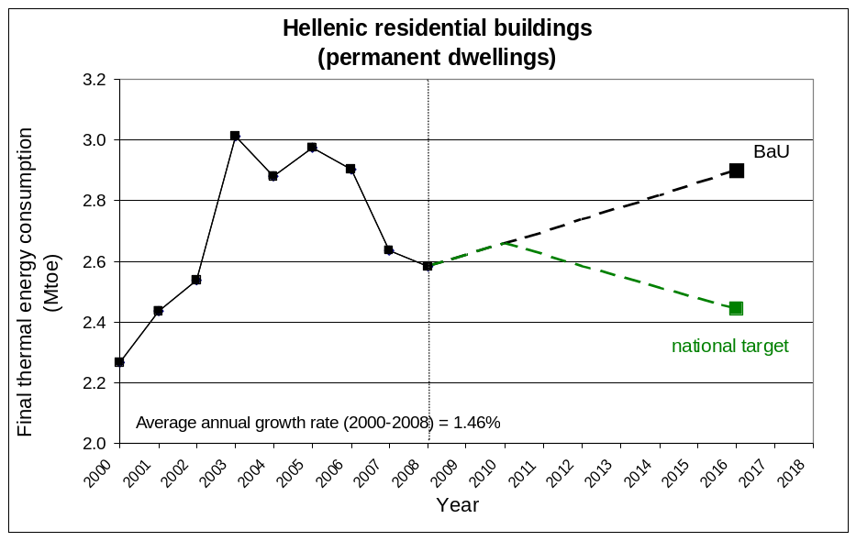

Table 45 summarizes the features of the two scenarios studied within the frame of TABULA.

Table 45: General description of Standard and Ambitious scenario
 |  | STANDARD SCENARIO | AMBITIOUS SCENARIO
Envelope | Add insulation | U-values foreseen by KENAK for each element according to climatic zone
Envelope | Replace windows | U-values foreseen by KENAK for each climatic zone Improve air tightness as necessary | Introduce double pane low-e
E/M Systems | Solar collectors | Cover up to 60% of DHW needs | Cover 100% of DHW needs + part of the space heating needs
E/M Systems | New boiler & controls | System efficiency foreseen by KENAK according to installed power
E/M Systems | Pipe insulation | System efficiency foreseen by KENAK according to transferred power
E/M Systems | Geothermal Heat Pump | -- | Use this technology if existing installations permit it

The TEE-KENAK software was used in order to calculate the energy savings achieved by applying the two scenarios to the typical buildings. Results are summarized in Table 46. Note that in some cases the estimated thermal energy savings correspond to a fuel switch, for example, from oil to electricity (i.e. replacing an oil boiler with a geothermal heat pump). The data in Table 46 refer to final thermal energy consumption and do not reflect the resulting increase of electrical energy consumption or the increased primary energy consumption for power generation. This is also elaborated in the following discussion.

Table 46: Calculated savings in the thermal energy consumption and in the total primary energy from the application of the Standard and Ambitious scenario in the typical buildings.
The (+) sign indicates that SFH buildings of the class use an oil boiler for both space and DHW heating.
Climatic Zone | Age Band | STANDARD SCENARIO |  |  |  | AMBITIOUS SCENARIO
Climatic Zone | Age Band | Thermal energy consumption savings (%) |  | Total primary energy savings (%) |  | Thermal energy consumption savings (%) |  | Total primary energy savings (%)
Climatic Zone | Age Band | SFH | MFH | SFH | MFH | SFH | MFH | SFH | MFH
A | 1 | 80.7 | 80.8 | 79.5 | 72.0 | 100.0 | 100.0 | 94.9 | 97.9
A | 2 | 80.1 | 63.5 | 75.5 | 61.3 | 100.0 | 100.0 | 95.8 | 95.6
A | 3 ⁽⁺⁾ | 12.6 | 33.9 | 12.1 | 48.1 | 62.8 | 90.3 | 61.8 | 94.3
B | 1 | 80.2 | 76.8 | 76.2 | 70.4 | 100.0 | 100.0 | 95.5 | 91.5
B | 2 ⁽⁺⁾ | 57.8 | 63.8 | 57.3 | 61.9 | 100.0 | 79.7 | 90.0 | 85.8
B | 3 | 26.4 | 29.0 | 29.5 | 40.7 | 46.8 | 60.5 | 60.7 | 74.1
C | 1 | 79.3 | 80.0 | 75.5 | 73.4 | 100.0 | 100.0 | 95.4 | 86.6
C | 2 | 60.5 | 61.9 | 60.5 | 60.5 | 100.0 | 76.4 | 91.2 | 80.9
C | 3 ⁽⁺⁾ | 37.6 | 42.3 | 43.0 | 48.6 | 57.0 | 66.3 | 66.6 | 77.8
D | 1 | 80.3 | 76.9 | 77.8 | 74.0 | 100.0 | 85.5 | 94.3 | 87.5
D | 2 | 40.1 | 46.1 | 46.0 | 49.3 | 62.1 | 63.8 | 73.7 | 72.1
D | 3 | 42.2 | 30.4 | 45.7 | 41.4 | 59.3 | 62.0 | 67.8 | 76.1

The energy conservation achieved through the two scenarios is very high, as they represent a holistic approach towards energy efficiency, affecting both the envelope and the installed systems and including RES for covering part of the demand. Since the present analysis focuses to thermal energy consumption (i.e. electrical energy consumption is not considered) Table 11 summarizes the related results for the two scenarios. As expected, the savings resulting from the Ambitious scenario are higher than those of the Standard scenario. The use of geothermal heat pumps minimizes the thermal energy consumption leading to savings close to 100%. However, this is replaced by an increase of the total electrical energy consumption. This will be added to the electrical energy balance (i.e. primary energy for power generation), thus the overall impact of the Ambitious scenario on the total energy balance will be smaller. However, further analysis of the energy balance is not possible since there is no official data reported on the breakdown of primary energy use of power generation for the different end-uses.

Application of the Standard and Ambitious scenarios could lead to a significant reduction in the energy consumption of the residential building sector. However, application of such scenarios on the entire building stock is not practical due to the associated high investment cost. Therefore, a more realistic assessment was attempted by considering the potential application of these scenarios on a percentage of the residential building stock with different energy savings potential.

Taking into account the calculated energy savings reported in Table 11 and the target value of thermal energy consumption for 2016, the energy balance model was used in order to derive the percentage of the building stock that will have to adopt the Standard or the Ambitious scenarios to achieve the target savings. Indicatively, it was found that the national target could be reached by applying the Standard scenario in 15% of the residential buildings of the first age band (built prior to 1980) and 30% of the buildings of the second age band (built between 1980 and 2000). The same could be achieved by applying the Ambitious scenario in 10% and 25% of the buildings in the corresponding age bands.

Apparently, it is possible to derive different combinations that could satisfy this goal. In a more strategic approach, a cost-benefit analysis could indicate the most appropriate combinations of building classes in which the adoption of such scenarios would maximize savings for different investment costs, based on fund availability and national priorities. However, this is beyond the scope of the present study.

Perspectives and Conclusions

The present work was performed in order to examine the possibility of the using the Hellenic building typology created within the framework of TABULA in modelling the national energy balance. An energy balance model was set up and tested against officially reported data, with success.

The results of the present model in absolute terms should be evaluated taking into account the assumptions that were necessary to make, in order to overcome the lack of available data and statistics regarding the residential building stock at the required level of detail. However, collaborative work with NAG experts from the field of building construction and energy monitoring has made it possible to feed the model with the data by making well justified estimates, where possible.

Some of the most important sources of uncertainty are related with the definition of:

- building classes
- typical buildings
- thermal characteristics of the typical buildings
- system expenditure coefficients of the typical buildings
- operational characteristics, e.g. operating hours of the heating system
- estimation of the heated floor area for each typology class

In the future, as more information on the residential building stock becomes available through the exploitation of the new data that becomes available from the ongoing building energy audits and generation of EPCs throughout the country, it will be possible to minimise the above sources of uncertainty and feed the model with updated official statistical data.

Nevertheless, the typology concept has proved to provide a flexible tool for estimating the impact of energy saving scenarios on the energy performance of the residential building stock.

Table 47: Sources / References Greece
Reference shortcut | Short description | Reference
[1] | National Scientific TABULA Report
[2] | National scientific report | D. Lalas, C.A. Balaras, A. Gaglia, E. Georgakopoulou, S. Mirasgentis, I. Serafidis, S. Psomas, “Evaluation of supporting policies for the advancement of the Ministry’s policies in relation to the abatement of CO₂ emissions in the residential and tertiary sectors”, 650 p., Institute for Environmental Research & Sustainable Development, National Observatory of Athens, and Ministry for the Environment, Physical Planning and Public Works, Directorate Urban Planning & Housing, November 2002 [in Hellenic].
[3] | Scientific paper | C.A. Balaras, A.G. Gaglia, E. Georgopoulou, S. Mirasgedis, Y. Sarafidis, D.P. Lalas. “European Residential Buildings and Empirical Assessment of the Hellenic Residential Building Stock, Energy Consumption Emissions and Potential Energy Savings”, Building & Environment, 42/3, 1298-1314 (2007).
[4] | Publication of the National Hellenic Statistical Service | NHSS. Results from the census of constructions—buildings of the December 1, 1990. Athens: National Hellenic Statistical Service; 2000 [in Hellenic].
[5] | Publication of the National Hellenic Statistical Service | NHSS. Results from the census of constructions—buildings of the December 1, 2000. Athens: National Hellenic Statistical Service; 2010 [in Hellenic].
[6] | Publication of the National Hellenic Statistical Service | NHSS. Research—energy consumption in households 1987–1988.Athens: National Hellenic Statistical Service; 1993 [in Hellenic].
[7] | Publication of the National Hellenic Statistical Service | NHSS. Statistics of building construction activity for the years 1995 and 1997. Athens: National Hellenic Statistical Service; 2000 [in Hellenic].
[8] | On line publication of the Hellenic Ministry of Environment and Climatic Change | http://195.251.42.2/cgi-bin/nisehist.sh?objtype=stats_query
[9] | Publication of the European Commission | EU energy and transport by figures. Statistical pocket book

Italy
(by TABULA partner POLITO / Italy)

Building Typology Approach

The six reference building-types used for the Energy Balance analysis are chosen within the “Building Type Matrix”. It has been defined for the “Middle Climatic Zone” that is the most representative of the Italian climate (about 4250 municipalities on a total number of 8100). The analysed building-types are the followings (see also Figure 3):
- single family house up to 1900 (“SFH.01”);
- single family house from 1921 to 1945 (“SFH.03”);
- multi-family house from 1946 to 1960 (“MFH.04”);
- apartment block from 1961 to 1975 (“AB.05”);
- apartment block from 1976 to 1990 (“AB.06”);
- apartment block from 1991 to 2005 (“AB.07”).

These reference buildings have been chosen according to statistical analysis: they are representative of a suitable significant portion of the entire national building stock considering both the construction age and the building size (i.e. number of apartments, floor area).
The first two reference buildings (single family houses) are “Theoretical Buildings” (“level 3“), characterized on the basis of statistical data (Piedmont Regional Database of Building Energy Performance Certificates). The other reference buildings (multi-family house and three apartment blocks) are “Example Buildings” (“level 1“).
In Figure 3 the “Building Type Matrix” of the “Middle Climatic Zone” shows the “Example Buildings” through a photo of the real building and the “Theoretical Buildings” through a photo of a real similar building.

Figure 3: Italian “Building Type Matrix” for the “Middle Climatic Zone”.
The building-types in the yellow cells are chosen as reference buildings for the Energy Balance analysis.
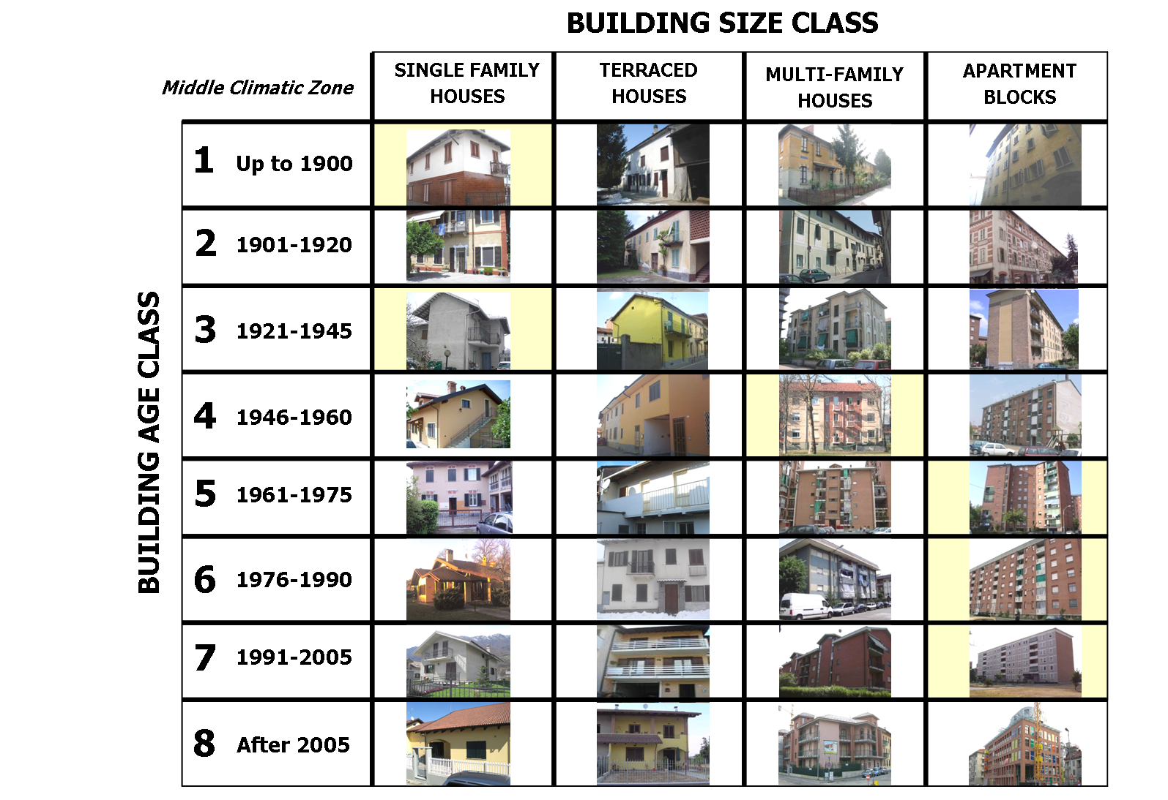

Available Data

National statistical Information about Buildings
Statistical information about buildings has been firstly obtained from the periodical report of the National Institute of Statistics (ISTAT - Report 2004).
Other interesting data have been extrapolated by the studies carried out by CRESME (Centre Economical, Social and Market Surveys in the Building Sector), in particular, CRESME Report 2006.
As regards national data about energy consumptions in buildings, the reference institution is ENEA (National Energy Agency): ENEA – Report 2008 has been analysed.
The following data summarize the main statistical information on the residential building stock in Italy:
- number of residential buildings: 11.226.595;
- number of apartments: 27.291.993;
- mean total living area: 96 m².
This information is also available split by Region (20 regions). Moreover, a number of additional data are available, both at national and at regional level.
In the present paragraph the information are given in terms both of National data and of “Middle Climatic Zone” data. The “Middle Climatic Zone” groups all those regions characterised by prevalent classification of the municipalities in the E Zone (from 2100 to 3000 heating degree-days). In those regions, the number of the municipalities falling in E Zone ranges from 58% (Marche region) to 87% (Lombardia region). In particular, Piedmont region is comprised within this group of regions with a percentage of 74% municipalities in E Zone.

Figures 3a and 3b show the number of buildings split by building age (related both to the national and the “Middle Climatic Zone” statistics).

Figure 4: National Statistics: buildings divided by their age
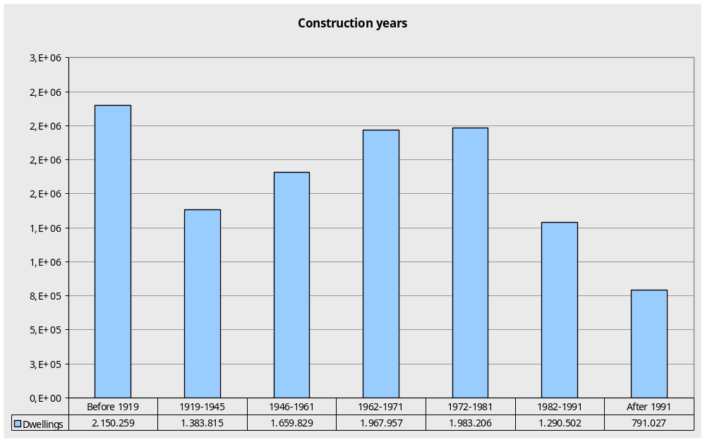

Figure 5: “Middle Climatic Zone” Statistics: buildings divided by their age
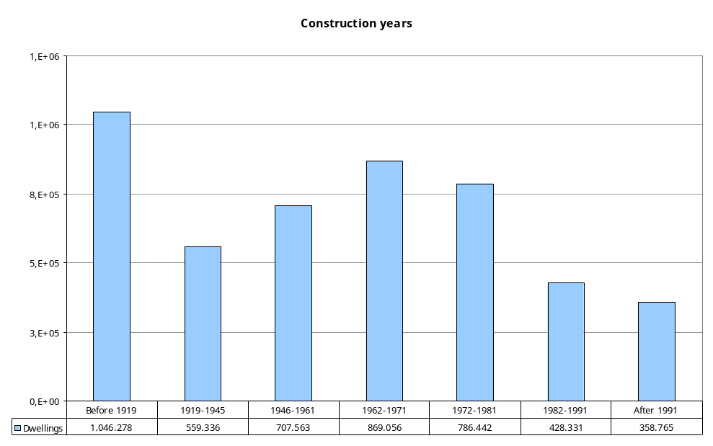

Figure 6 and Figure 7 show the number of apartments in buildings split by building age and number of apartments (related both to the national and the “Middle Climatic Zone” statistics).

Figure 6: National Statistics: number of apartments in residential buildings
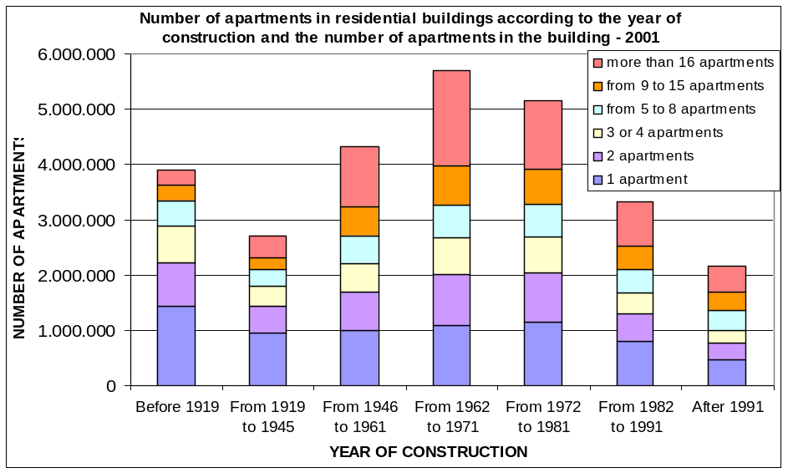

Figure 7: “Middle Climatic Zone” Statistics: number of apartments in residential buildings
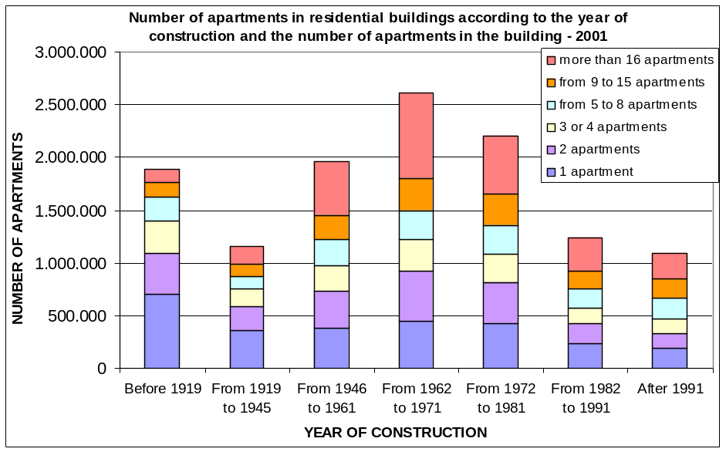

Moreover other information are available in terms of statistics, in particular:
- number of buildings split by building size (expressed in terms of net floor area, m²);
- retrofit/modernisation actions over the last 10 years (expressed in terms of actions related to building services, structural elements and non-structural elements);
- number of buildings divided by heating and domestic hot water systems (individual and centralized systems);
- number of buildings divided by type of fuel for space heating and DHW;
- breakdown of final energy uses in residential buildings (Figure 5).

Figure 8: Residential final consumption breakdown (national statistics)
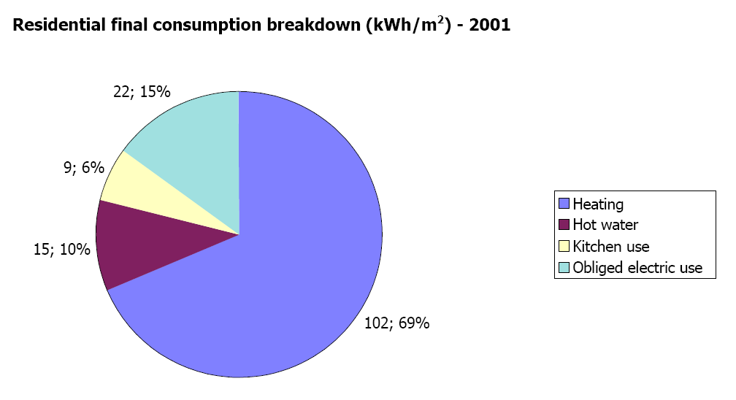

In particular, data from Piedmont Regional Database of Building Energy Performance Certificates (more than 50.000 EP certificates, including apartments) are available. In Figure 9, the buildings shown by the certificates are divided in terms of percentage among single family houses, terraced houses, multifamily houses and apartment blocks.

Figure 9: Breakdown of building types (Piedmont region)


For these buildings, a number of statistical information are available, in particular:
- number of buildings divided by building age (see Figure 10);
- number of buildings divided by building size (expressed in terms of heated floor area, in m², and volume, in m³);
- mean U-value for the opaque and transparent envelope divided by building age;
- primary energy demand for heating (kWh/m²) divided by building age (Figure 11).

Figure 10: Frequencies of single family houses according to building age class (Piedmont region)
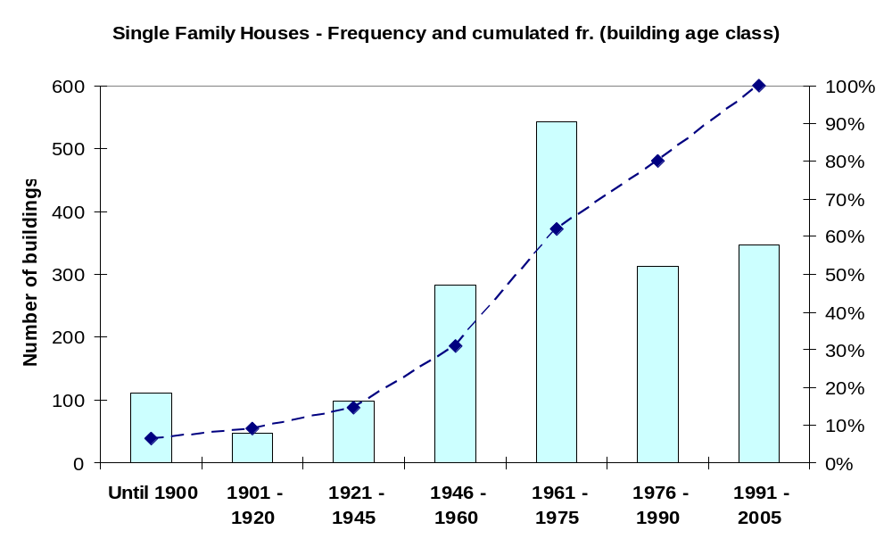

Figure 11: Primary energy demand of single family houses (Piedmont region)
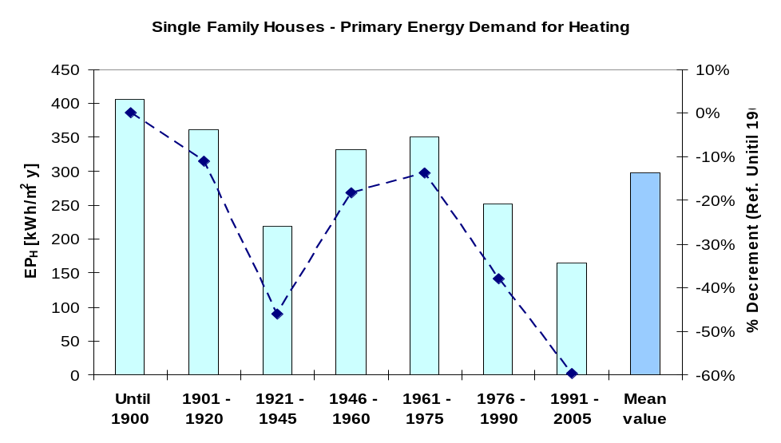

Energy Balance Method

The procedure applied for Energy Balance Method is shown in Figure 12. Starting from global statistic at National and Regional level and from the corresponding available residential building sample for ”Middle Climatic Zone” divided in “Classes” (in terms of Age and Shape), 6 reference buildings have been selected in order to obtain a relevant characterization of the analyzed buildings. They have been chosen as representative of a large portion of the national residential building stock as regards the “Middle Climatic Zone” (for age of construction and building size), as highlighted in Figure 3.
Figure 12: Procedure for energy balance
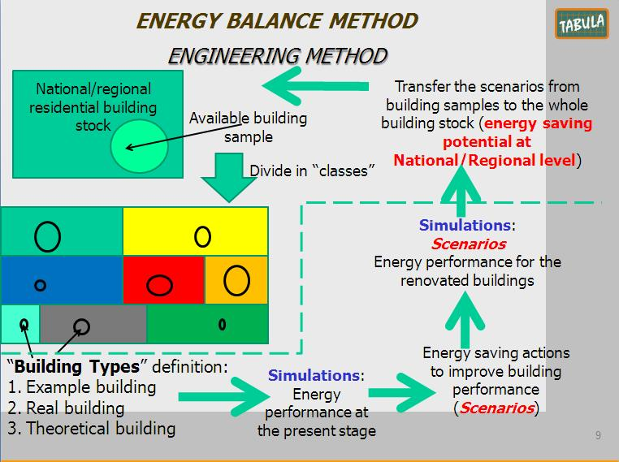

The official national calculation method (Technical Specification UNI/TS 11300 - National Annex to CEN Standards) for energy certificates has been applied for the evaluation of the energy demand of the selected reference buildings and to assess the energy saving potential due to energy retrofit actions according to 2 different scenarios (standard and advanced retrofit actions).
The retrofit scenarios have been firstly applied to the 6 selected reference buildings; than the obtained results have been statistically enlarged to the whole building stock of “Middle Climatic Zone”: each reference building is in fact considered as representative of a suitable portion of the building stock. As a consequence, energy saving potentials have been assessed.

The following simplifications and assumptions have been adopted for the calculations:
- climatic data of the city of Turin (for “Middle Climatic Zone”) from a national technical standard (UNI 10349);
- natural ventilation rate fixed at 0,3 h⁻¹;
- simplified calculation of internal heat gains according to UNI/TS 11300-1 (fit for residential buildings);
- simplified calculation of building internal heat capacity according to UNI/TS 11300-1 (pre-determined value defined on the type of building components, heavy or light);
- simplified calculation of thermal bridges according to UNI/TS 11300-1 (pre-determined percentage increase of thermal transmittance);
- simplified calculation of indoor air temperature of unconditioned spaces according to UNI/TS 11300-1 (pre-determined value defined on the type of space);
- neither shading devices nor shutters installed on windows;
- reduction factor for shading by permanent obstructions fixed at 0,8 for all windows;
- reduction factor for window frame (frame factor) fixed at 0,2;
- pre-calculated efficiency values of heating and DHW systems according to UNI/TS 11300-2 (emission, distribution and generation subsystems).

Energy Balance of the Residential Building Stock

The results of the energy performance of the six selected reference building-types (“RBT”) are shown in Table 48.
The following different quantities of energy balance are concerned:
- net energy need for space heating (Q_{H,nd,RBT});
- net energy need for domestic hot water (Q_{W,nd,RBT});
- primary energy demand for space heating (Q_{H,p,RBT});
- primary energy demand for domestic hot water (Q_{W,p,RBT});
- primary energy demand for space heating and domestic hot water (Q_{H,W,p,RBT});
- CO₂ emissions (referred to both heating and DHW; t_{CO2,RBT}).

Table 48: Results of the calculations for different quantities of energy balance referred to the six reference building-types
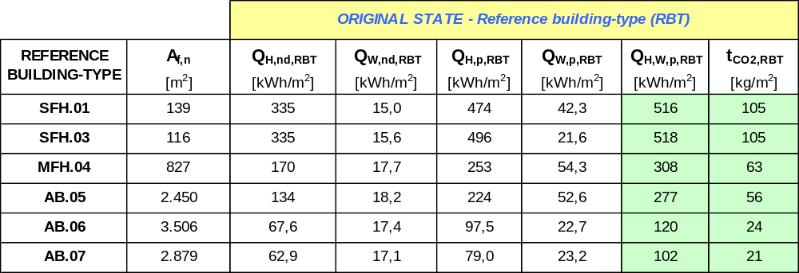
.

The energy performance of each reference building-type has been projected to the whole residential building stock of “Middle Climatic Zone” according to the available frequency data on dwellings (Figure 4b) split by construction age. Each reference building is defined as the most frequent building-type in the age of construction that it represents (see also Figure 6b). The results of the projection from the reference buildings (RBT) to the residential building stock (RBS) are shown in Table 49, in which the same energy quantities of Table 48 are considered.

Table 49: Projection of the energy performance of the six reference building-types (RBT) to the residential building stock (RBS) according to “Middle Climatic Zone” statistical data on the frequency of buildings
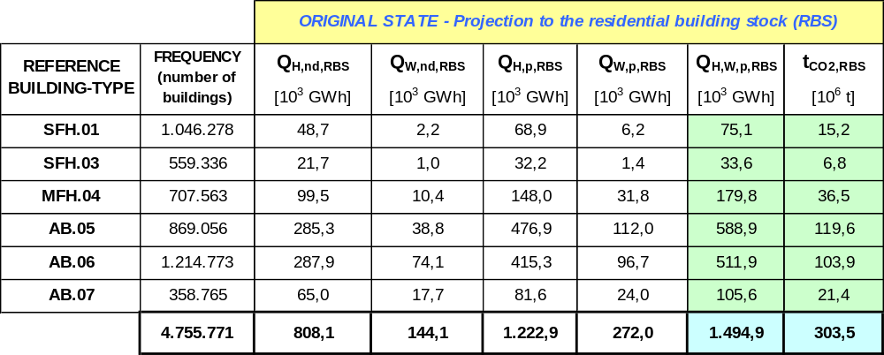

Each energy quantity expressed in kWh/m² (for RBT) in Table 48 is transformed in 10³ GWh (for RBS) in Table 49 by multiplying it for the useful floor area of the reference building and the frequency (i.e. the number of buildings) in the building stock. The conversion from the energy quantity to the CO₂ emission is made considering a reference emission factor of the natural gas (230 g/kWh) as the most used fuel in Italy by statistics.

Comparison to National Statistical Data of the Residential Building Stock
The calculated energy consumption (RBS,CALC) can be compared with the available statistical data (RBS,STAT) of the residential building stock only as regards the primary energy for space heating because of the lack of consistent statistical values for the other energy quantities (net energy need for space heating and DHW, etc.). However an important reference statistical value is available: it represents the annual value of primary energy need for heating normalised to the unitary useful floor area (Q_{H,p,RBS,STAT}), as shown in Table 26.
So the comparison is made between Q_{H,p,RBS,CALC} (kWh/m²) and Q_{H,p,RBS,STAT} (kWh/m²); the former is obtained dividing the primary energy consumption of the building stock in 10³ GWh (see also Table 49) by the total number of buildings and the useful floor area of a mean dwelling in the building stock.
The values of Q_{H,p,RBS,CALC} and Q_{H,p,RBS,STAT} are quite different; this is mainly due to a difference in the system operation time. In fact the calculation of the energy need for heating (according to National technical standards) is performed considering a continuous system operation (24 hours every day), while in reality it occurs a system intermittency. In order to compare the calculated value of energy consumption and the measured one (statistical value), the calculated value is corrected applying a reduction factor according to EN ISO 13790. This factor (called a_{H,red} in the technical standard) considers both the real hours of heating operation (14 hours a day for E Zone) and the seasonal heat gains to heat losses ratio and the building thermal inertia. The thermal inertia is expressed through the time constant of the building. The values of these parameters are determined considering each reference building-type. The corrected calculated value (Q_{H,p,RBS,CORR}) is reported in Table 26. The difference between the corrected calculated value and the statistical value can be explained considering the internal set-point temperature: the value used in the calculation is 20 °C, while the real set-point temperature is often 1,5-2 °C higher, due to thermal comfort reasons.
Table 50: Comparison between the calculated value and the statistical data of primary energy for space heating with reference to the residential building stock of “Middle Climatic Zone”
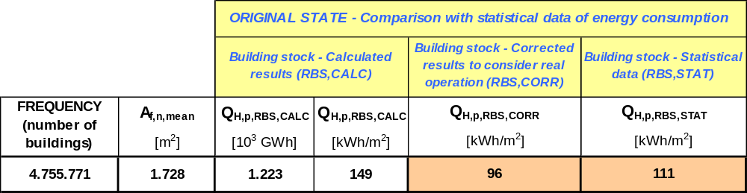
.

Calculation of Energy Saving Potentials

For each reference building-type two refurbishment measures have been considered, a standard and an advanced one, for both the building envelope and the technical systems (space heating and DHW). The following standard refurbishment measures have been applied to the envelope:
- application of insulation material on walls to reach an U-value of 0,33 W/(m² K);
- application of insulation material on floors and roofs to reach an U-value of 0,30 W/(m² K);
- replacement of windows to reach an U-value of 2,00 W/(m² K).
The following advanced refurbishment measures have been applied to the envelope:
- application of insulation material on walls to reach an U-value of 0,25 W/(m² K);
- application of insulation material on floors and roofs to reach an U-value of 0,23 W/(m² K);
- replacement of windows to reach an U-value of 1,70 W/(m² K).
The considered U-values correspond to the requirements established by the new regulations on energy performance of buildings in Piedmont Region (D.G.R. n. 46-11968). These U-values are more restrictive in comparison to those established by the National legislation (Legislative Decree n.192/2005). The U-values applied for the standard refurbishment are the compulsory U-values in the Piedmont Region regulation, while the U-values applied for the advanced refurbishment are the optional U-values in the Piedmont Regional regulation.
As regards the refurbishment of the heating system, the following measures have been considered both for the standard and for the advanced level:
- replacement of radiators with radiant heating panels;
- insulation of the distribution subsystem;
- replacement or new installation of a heat storage (high insulation level);
- replacement of individual heating systems (per apartment) with central heating system.

As regards the standard refurbishment of the heating generator subsystem, the following heat generators have been considered for the six reference buildings:
- condensing boiler (SFH.01, MFH.04, AB.05, AB.07);
- air-to-water heat pump (SFH.03, AB.06).
As regards the advanced refurbishment of the heating generator subsystem, the following heat generators have been considered for the six reference buildings:
- geothermal heat pump (MFH.04, AB.07);
- geothermal heat pump coupled with thermal solar plant (SFH.03);
- condensing boiler coupled with thermal solar plant (SFH.01, AB.05);
- air-to-water heat pump coupled with thermal solar plant (AB.06).

The refurbishment of the DHW system has been hypothesized considering the following measures for both the standard and the advanced level:
- insulation of the distribution subsystem;
- replacement or new installation of a heat storage (high insulation level);
- in some case, replacement of individual DHW systems (per apartment) with central DHW system.

Moreover, as regards the standard refurbishment of the DHW generator subsystem, the following heat generators have been considered for the six reference buildings:
- condensing boiler and individual DHW production, per apartment (SFH.03, MFH.04, AB.06, AB.07);
- condensing boiler and central DHW production (SFH.01, AB.05).

As regards the advanced refurbishment of the DHW generator subsystem, the following heat generators have been considered for the six reference buildings:
- geothermal heat pump (MFH.04, AB.07);
- geothermal heat pump coupled with thermal solar plant (SFH.03);
- condensing boiler coupled with thermal solar plant (SFH.01, AB.05, AB.06).

The calculated energy saving potentials (primary energy) for the six refurbished reference buildings (RBT) and for the building stock (RBS) are shown in Table 51 and in Table 52, respectively for the standard and the advanced level of refurbishment. The CO₂ emission reducing potentials are indicated too. In order to obtain realistic values of the saving potentials (primary energy and CO₂ emissions reduction) due to the refurbishment of the residential building stock, the calculated value has been calibrated according to the real operation of the heating system (RBS,CORR) as done for the comparison with statistical data (see par. 2.4.4 and Table 50).

Table 51: Calculated energy saving and CO₂ emission reduction potentials by standard refurbishment (both for the reference building-types and the residential building stock of “Middle Climatic Zone”)
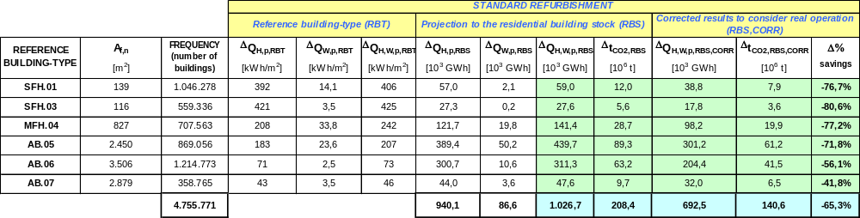

Table 52: Calculated energy saving and CO₂ emission reduction potentials by advanced refurbishment (both for the reference building-types and the residential building stock of “Middle Climatic Zone”)
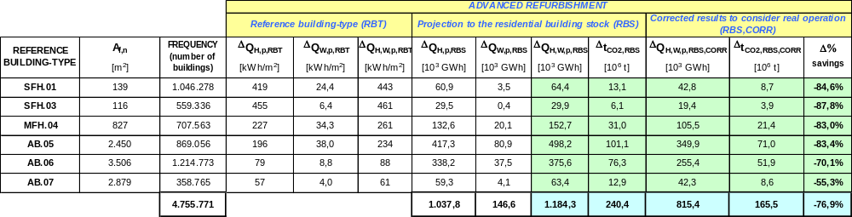

Perspectives and Conclusions

Conclusions
The performed study shows the high potentiality in terms of energy saving related to retrofit actions on existing buildings for the Italian “Middle Climatic Zone”, grouping the highest portion of the Italian residential building stock.
In Italy in general, and in the Italian “Middle Climatic Zone” in particular, the statistical distribution of the number of buildings as a function of the construction age shows a high amount of buildings dated before the emanation of energy laws: as a consequence they are characterized by low energy performance and also the application of basic energy renovations may provide significant increases of the energy performance and consequent reductions of CO₂ emissions. In fact the standard refurbishment level already shows the high potentiality of energy savings up to 80%.
The proposed methodology is an useful tool to define a clear picture for the most representative climatic zone in Italy.

Perspectives
A possible increase of the accuracy of the results can be obtained enlarging the building types used as a reference for the National Energy Balance: to this aim statistics at National level are required for a more detailed division of the number of buildings according to the building typology. Moreover the same methodology could be applied also to the other two Italian climatic zones (Alpine and Mediterranean).
The same approach can be also performed for a deeper analysis at Piedmont regional level where more detailed data are available for a better description of the building-type used for “Regional Energy Balance”.
In general the performed study allowed to define a clear methodology fit for National Energy Balance. The assessed energy consumptions and savings are sufficiently accurate when compared with actual energy consumptions based on National-Regional statistics.

Table 53: Sources / References Italy
Reference shortcut | Short description | Reference
... | national scientific TABULA report | …
ISTAT - Report 2004 | Report from ISTAT - National Institute of Statistics. | Rapporto ISTAT 2004 – Istituto Nazionale di Statistica.
CRESME - Report 2006 | Report from CRESME - Centre Economical, Social and Market Surveys in the Building Sector. | Rapporto CRESME 2006 – Centro Ricerche Economiche Sociali di Mercato per l’Edilizia e il territorio.
ENEA – Report 2008 | Report from ENEA - National Energy Agency. | Rapporto ENEA 2008 – Agenzia nazionale per l’energia.
D.Lgs. 192/2005 – D.Lgs. 311/2006 | National regulation on the transposition of the EBPD in Italy. | Decreto legislativo 29 dicembre 2006, n. 311, “Disposizioni correttive ed integrative al decreto legislativo 19 agosto 2005, n. 192, recante attuazione della direttiva 2002/91/CE, relativa al rendimento energetico in edilizia”.
D.G.R. 46-11968 (2009) | Regional regulation (Piedmont Region) on minimum energy performance requirements of buildings. | Deliberazione della Giunta Regionale 4 agosto 2009, n. 46-11968. Aggiornamento del Piano regionale per il risanamento e la tutela della qualità dell'aria - Stralcio di piano per il riscaldamento ambientale e il condizionamento e disposizioni attuative in materia di rendimento energetico nell'edilizia ai sensi dell'articolo 21, comma 1, lettere a) b) e q) della legge regionale 28 maggio 2007, n. 13 "Disposizioni in materia di rendimento energetico nell'edilizia".
EN ISO 13790:2008 | European Standard. Energy performance of buildings - Calculation of energy use for space heating and cooling | Prestazione energetica degli edifici - Calcolo del fabbisogno di energia per il riscaldamento e il raffrescamento
UNI/TS 11300-1:2008 | National technical specification. Annex to CEN Standard EN ISO 13790. | Prestazioni energetiche degli edifici. Parte 1: Determinazione del fabbisogno di energia termica dell’edificio per la climatizzazione estiva ed invernale.
UNI/TS 11300-2:2008 | National technical specification . Energy performance of buildings – Calculation of primary energy and efficiencies for space heating and domestic hot water. | Prestazioni energetiche degli edifici. Parte 2: Determinazione del fabbisogno di energia primaria e dei rendimenti per la climatizzazione invernale e per la produzione di acqua calda sanitaria.
prUNI/TS 11300-4 | National technical specification. Calculation of the energy performance of buildings – Use of renewable energy sources for heating and domestic hot water (in preparation). | Prestazioni energetiche degli edifici. Parte 4: Utilizzo di energie rinnovabili e di altri metodi di generazione per riscaldamento di ambienti e preparazione acqua calda sanitaria (in corso di elaborazione).
UNI 10349:1994 | National Technical Standard (UNI). Climatic data. | Riscaldamento e raffrescamento degli edifici. Dati climatici.

Slovenia
(by TABULA partner ZRMK / Slovenia)

Building Typology Approach
Slovenian TABULA Typology was elaborated with 4 building types (SFH - single family house, TH - terraced house, MFH - multifamily house and AP - apartment block) and 6 age classes:
- until 1945 (1) – pre WWII period
- 1945 – 1970 (2) – after WWII period, no thermal regulations
- 1971 – 1980 (3) – first national regulation on energy saving protection of buildings
- 1981 – 2002 (4) – revision of regulation
- 2003 – 2008 (5) – first energy performance calculation methodology based on European standards
- from 2009 (6) – latest energy performance regulations

For calculation of national energy balance only 2 condensed building types (single unit buildings - SUB and multi-unit buildings - MUB) were used, thus combining SFH + TH into SUB and MFH + AB into MUB respectably. Furthermore first to age classes were grouped into single year class (until 1970) living us with 5 age classes. This gives us 10 primary building types.

Table 54: Frequencies of 10 building types in 2009
Building type | number of  buildings | number of  apartments | living space  in 1000 m2 | TABULA  reference  area in 1000 m2
SUH.01 (until 1970) | 256.125 | 276.993 | 24.792 | 27.271 | Single Unit Houses
SUH.02 (1971 – 1980) | 90.189 | 96.958 | 9.718 | 10.690 | Single Unit Houses
SUH.03 (1981 – 2002) | 122.862 | 128.048 | 12.981 | 14.280 | Single Unit Houses
SUH.04 (2003 – 2008) | 23.961 | 24.668 | 2.844 | 3.129 | Single Unit Houses
SUH.05 (from 2009) | 146 | 158 | 14 | 15 | Single Unit Houses
MUH.01 (until 1970) | 17.650 | 178.890 | 9.344 | 10.278 | Multi Unit  Houses
MUH.02 (1971 – 1980) | 3.165 | 66.905 | 3.216 | 3.538 | Multi Unit  Houses
MUH.03 (1981 – 2002) | 3.074 | 57.282 | 2.909 | 3.200 | Multi Unit  Houses
MUH.04 (2003 – 2008) | 1.408 | 21.630 | 1.274 | 1.401 | Multi Unit  Houses
MUH.05 (from 2009) | 18 | 1.161 | 71 | 78 | Multi Unit  Houses
Building Stock total | 518.598 | 852.693 | 67.164 | 73.881

Source: Registry of buildings [REN]

Primary building types describe original state of buildings at the time of erection. Since then buildings have changed and for the calculation of current national balance we have to take into consideration changed, refurbished, present buildings. Thus we investigated sub typologies. Subdivisions ware made according to a) level of refurbishment (un-refurbished, medium or full refurbishment) or b) level of thermal protection of building at the time of erection (standard level, high standard level, or low energy level). Figure 13 on next page shows these subdivisions.

Figure 13: Division of primary building types into present state building types
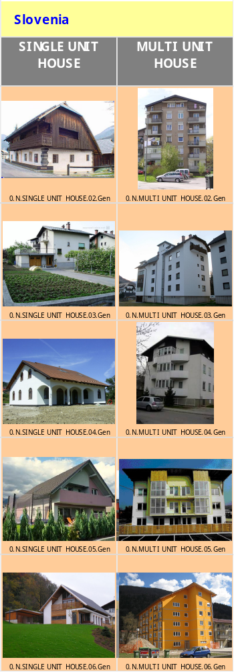
Un - refurbished
Medium refur.
Full refur.
Un - refurbished
Medium refur.
Full refur.
Un - refurbished
Medium refur.
Full refur.
Standard
High standard
Low Energy
High standard
Low Energy

28 building types where calculated in Slovenian national balance. Buildings representing these types where “real” example buildings (10 real geometries, ReEx) with assigned different “real” thermal insulation thickness and windows types to represent subdivisions.

Available Data

Registry of buildings of Slovenia [REN] is a large database. It includes all of the country buildings with some information interesting for energy calculations. This are: year of building erection, area and utilisation of building part (apartment), year of windows, roof and wall refurbishment, number of storeys and type of heat generation. The database is constantly updating. For our calculation we used data from 2007.
Combination of information about the year of refurbishment of wall, roof and windows with the knowledge about the level of refurbishment at that time gave us an insight into today state of those buildings. These steps where made with some assumptions:
- Roof: half of refurbishment with no thermal improvement, before 2002 → 10 cm of thermal insulation, after 2002 → 20 cm of thermal insulation,
- Walls: before 1996 → 5 cm of thermal insulation, after 1996 → 8 cm of insulation,
- Windows: before 1996 → U = 2,7 W/m²K, after 1996 → U = 1,4 W/m²K.
One building could have several refurbishment measure taken in the past. Combination of those measures gives us possibility to define such building as one of subtypes (blue arrows in Figure 13).
To divide newer buildings (from 2003) that have not been refurbished into 3 thermal protection levels (red arrows) we made further assumptions based on our experience.

Table 55: Frequencies of sub – building types (% of number of buildings in building type)
Building Type |  | Distribution
SUH.04.Standard | 55 % |  | Single Unit  Houses
SUH.04.High_stand | 40 % |  | Single Unit  Houses
SUH.04.Low_E | 5 % |  | Single Unit  Houses
SUH.05.High_stand | 95 % |  | Single Unit  Houses
SUH.05.Low_E | 5 % |  | Single Unit  Houses
MUH.04.Standard | 65 % |  | Multi Unit  Houses
MUH.04.High_stand | 35 % |  | Multi Unit  Houses
MUH.04.Low_E | 5 % |  | Multi Unit  Houses
MUH.05.High_stand | 99 % |  | Multi Unit  Houses
MUH.05.Low_E | 1 % |  | Multi Unit  Houses

Less data is available regarding systems installed.

Table 56: Frequencies of different systems for heating
(% of number of buildings of residential buildings)
Building type | no  heating | central  heating | other  heating | district  heating | no  data | Total
SUH.01 | 5,7% | 31,7% | 11,4% | 0,5% | 0,1% | 49% | Single Unit Houses
SUH.02 | 0,7% | 14,8% | 1,7% | 0,2% | 0,0% | 17% | Single Unit Houses
SUH.03 | 1,4% | 20,1% | 2,0% | 0,2% | 0,0% | 24% | Single Unit Houses
SUH.04 | 0,7% | 3,6% | 0,3% | 0,0% | 0,0% | 5% | Single Unit Houses
SUH.05 | 0,0% | 0,0% | 0,0% | 0,0% | 0,0% | 0% | Single Unit Houses
MUH.01 | 0,1% | 1,9% | 0,9% | 0,4% | 0,0% | 3% | Multi Unit  Houses
MUH.02 | 0,0% | 0,4% | 0,1% | 0,1% | 0,0% | 1% | Multi Unit  Houses
MUH.03 | 0,0% | 0,4% | 0,0% | 0,1% | 0,0% | 1% | Multi Unit  Houses
MUH.04 | 0,0% | 0,2% | 0,0% | 0,0% | 0,0% | 0% | Multi Unit  Houses
MUH.05 | 0,0% | 0,0% | 0,0% | 0,0% | 0,0% | 0% | Multi Unit  Houses
Building Stock total | 9% | 73% | 16% | 2% | 0% | 518.598

Source: Registry of buildings [REN]

Data about Slovenian typology with its subtypes is dated in year 2007. To calculate energy balance for the year 2011 (Table 57) we had to take into consideration the average yearly rate of building modernisation (building moves from class SUH.01.Un_refur to class SUH.01.Med_refur), rate of building demolition (only in oldest year class) and rate of new buildings erection. Data for these trends was available from Registry of Buildings and National statistics.

Table 57: Frequencies of building types (% of useful floor area in 1.000 m²) in 2011
Single Unit  Buildings | Floor area in 1.000 m2 | Tabula reference area in 1.000 m² | % of SUH | Multi Unit  Buildings | Floor area in 1.000 m2 | Tabula reference area in 1.000 m² | % of MUH
SUH.01.Un_refur | 9.790 | 10.769 | 18,9% | MUH.01.Un_refur | 4.070 | 4.477 | 23,2%
SUH.01.Med_refur | 10.314 | 11.345 | 19,9% | MUH.01.Med_refur | 3.803 | 4.183 | 21,7%
SUH.01.Full_refur | 4.238 | 4.661 | 8,2% | MUH.01.Full_refur | 1.201 | 1.322 | 6,8%
SUH.02.Un_refur | 5.302 | 5.833 | 10,2% | MUH.02.Un_refur | 1.752 | 1.927 | 10,0%
SUH.02.Med_refur | 3.137 | 3.450 | 6,1% | MUH.02.Med_refur | 1.094 | 1.203 | 6,2%
SUH.02.Full_refur | 1.101 | 1.211 | 2,1% | MUH.02.Full_refur | 293 | 322 | 1,7%
SUH.03.Un_refur | 8.615 | 9.476 | 16,6% | MUH.03.Un_refur | 1.866 | 2.052 | 10,6%
SUH.03.Med_refur | 3.947 | 4.342 | 7,6% | MUH.03.Med_refur | 985 | 1.084 | 5,6%
SUH.03.Full_refur | 518 | 570 | 1,0% | MUH.03.Full_refur | 123 | 135 | 0,7%
SUH.04.Standard | 1.673 | 1.840 | 3,2% | MUH.04.Standard | 894 | 984 | 5,1%
SUH.04.High_stand | 1.216 | 1.338 | 2,4% | MUH.04.High_stand | 522 | 574 | 3,0%
SUH.04.Low_E | 152 | 167 | 0,3% | MUH.04.Low_E | 75 | 82 | 0,4%
SUH.05.High_stand | 1.668 | 1.835 | 3,2% | MUH.05.High_stand | 864 | 950 | 4,9%
SUH.05.Low_E | 88 | 97 | 0,2% | MUH.05.Low_E | 9 | 10 | 0,0%
 | 51.758 | 56.934 | 100% |  | 17.549 | 19.304 | 100%
Source: Registry of buildings [REN]

Energy Balance Method

For each of 28 building types total energy use and primary energy consumption was calculated with software according to National methodology based on CEN standards [PURES] (Heating and cooling demand is calculated with monthly method according to EN ISO 13790:2008). Internal temperature was set to 20 °C with intermitted heating where heat generator is off for 25% of time.
Systems installed in each of the real example buildings where heating system and DHW preparation system that are most probable (based on experiences and not on reliable statistical data). For example: old single unit building has an old real example boiler that is located in unheated room. Energy carrier was chosen according to national statistic about energy use in buildings.

Energy Balance of the Residential Building Stock

Energy balance model calculated energy performance indicators for each of the 28 subtypes. In Table 58 are summarized some of those indicators into building type (heating need, final energy for domestic hot water preparation, electrical energy for lightning). Primary energy was calculated with factors from [PURES] and CO₂ emissions from data from Statistical office [STAT].

Table 58: Heat consumption of the Slovenian residential building stock (2011) for space heating, hot water and lighting
Building type | Heating need  (Qnh) | DHW final  (Qf,w) | lightning final  (W,f) | Final energy  (Q,f) | Primary  energy | CO2  emissions
SUH.01 | 2.937 GWh | 454 GWh | 363 GWh | 3.722 GWh | 4.829 GWh | 978 kt
SUH.02 | 2.094 GWh | 113 GWh | 209 GWh | 2.538 GWh | 3.085 GWh | 956 kt
SUH.03 | 1.285 GWh | 323 GWh | 202 GWh | 1.534 GWh | 2.004 GWh | 684 kt
SUH.04 | 154 GWh | 57 GWh | 36 GWh | 199 GWh | 264 GWh | 71 kt
SUH.05 | 88 GWh | 64 GWh | 20 GWh | 116 GWh | 155 GWh | 47 kt
MUH.01 | 1.262 GWh | 145 GWh | 290 GWh | 1.767 GWh | 2.363 GWh | 792 kt
MUH.02 | 356 GWh | 64 GWh | 40 GWh | 410 GWh | 517 GWh | 151 kt
MUH.03 | 280 GWh | 57 GWh | 36 GWh | 325 GWh | 436 GWh | 162 kt
MUH.04 | 95 GWh | 28 GWh | 16 GWh | 133 GWh | 181 GWh | 68 kt
MUH.05 | 28 GWh | 15 GWh | 9 GWh | 45 GWh | 64 GWh | 25 kt
Total | 8.580 GWh | 1.320 GWh | 1.219 GWh | 10.791 GWh | 13.898 GWh | 3.934 kt

Table 59 shows primary energy consumption and CO2 emissions by energy carrier.

Table 59: Primary energy consumption and CO₂ emissions of the Slovenian residential building stock (2011) for space heating, hot water and lighting by energy carrier
Energy carrier | Primary energy | CO2 emissions
Oil | 4.506 GWh | 1.194 kt
Gas | 1.066 GWh | 213 kt
District heating | 1.254 GWh | 414 kt
Electricity | 3.986 GWh | 2.113 kt
Other RES | 2 GWh | 0 kt
Biomass | 3.084 GWh | 0 kt
Coal | 0 GWh | 0 kt
Total | 13.898 GWh | 3.934 kt

Comparison to National Statistical Data of the Residential Building Stock
For comparison purposes different statistical data for different time periods were investigated. These data includes also energy use for cooking and other home appliances that is not calculated in energy balance model. Methodology for energy performance calculation uses climatic data averages for last 30 years. To compare results of our model and national statistical data we took average of three available sources (Table 60).
There is large deviation in electricity and biomass consumption. This originates in DHW preparation (electricity, model calculates not realistic energy needs for DHW) and cooking (biomass is used in Slovenia for stoves for cooking).
Gas is used for cooking, but this is not evident from the results. Total energy consumption is very close to calculated results but considering the roughness of the model one can conclude that this is more of coincidence.

Table 60: Comparison of model results with national energy statistics
Energy carrier | National Action Program  2001 – 2005 (average)  [AP] | Final energy consumption by energy source, households  2002  [STAT] | Energy balance  households  2007 – 2009 (average)  [STAT] | Average | Calculated | Deviation
Oil | 4.943 GWh | 5.462 GWh | 3.477 GWh | 4.627 GWh | 4.506 GWh | -3%
Gas | 1.049 GWh | 805 GWh | 1.268 GWh | 1.041 GWh | 1.066 GWh | 2%
District heating | 1.203 GWh | 1.339 GWh | 1.120 GWh | 1.221 GWh | 1.254 GWh | 3%
Electricity | 2.873 GWh | 2.821 GWh | 3.117 GWh | 2.937 GWh | 3.986 GWh | 36%
Other RES | 0 GWh | 0 GWh | 0 GWh | 0 GWh | 2 GWh | -
Biomass | 3.847 GWh | 3.770 GWh | 3.768 GWh | 3.795 GWh | 3.084 GWh | -19%
Coal | 58 GWh | 219 GWh | 0 GWh | 92 GWh | 0 GWh | -
Total | 13.972 GWh | 14.415 GWh | 12.750 GWh | 13.713 GWh | 13.898 GWh | 1%

Calculation of Energy Saving Potentials

Energy balance models are especially useful for calculation of energy savings. Slovenian model was used for designing different refurbishment scenarios of external wall. For these purpose new subtypes were defined (letter F was added). This new subtypes represent existing buildings with refurbished façade. Only buildings from 01, 02 and 03 year class would undergo refurbishment in upcoming years.

Figure 14: Potential for wall refurbishment (end of 2010), only buildings in first three year classes will undergo external wall refurbishment until 2020
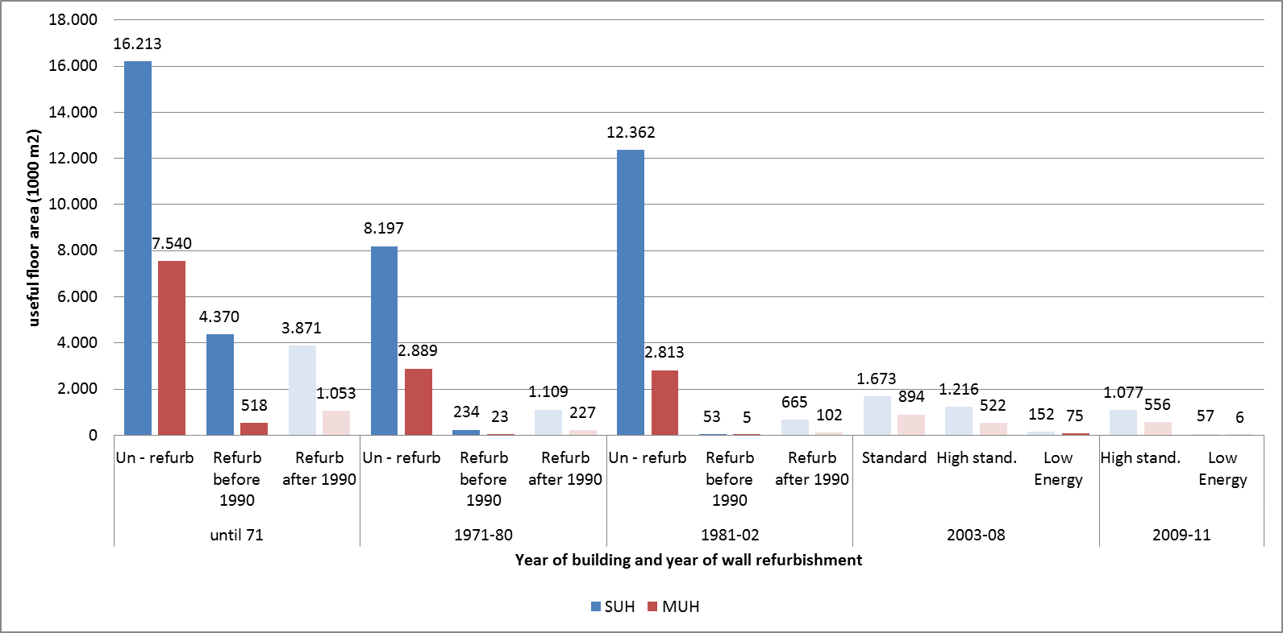

Refurbishment measure was realistically set (8 cm of new thermal insulation if there was some kind of thermal insulation already present and 15 cm of new thermal insulation for building with no thermal protection). For example: SUH.01.Un_refur with no thermal insulation will be insulated with 15 cm and this will become new sub type SUH.01.Un_refur.F.
Then 2 scenarios where investigated: normal scenario and ambitious scenario. In 2010 1,9 % of residential building stocks walls where insulated (only 0,14 % with national subsidies). This was taken as a normal scenario. On the other hand more ambitious rate of 6 % was proposed. Algorithm based on past experiences and National Energy Program was built that describes fluctuation of buildings between building sub types.
Erection of new building, old buildings demolition and other type of refurbishment where taking into account as well.
Table 61 shows heated area of first SUH year class for present state and for two different scenario. One can observe big difference between numbers of old SUH that are still unrefurbished (first row of data, this buildings where build before 1971 and will be at least 50 years old in 2020).

Table 61: Example of total floor area per building type in 2011 and for two scenarios in 2020

Building sub type | Area  2011  (1.000 m2) | Area  2020, 1,9%  (1.000 m2) | Area  2020, 6%  (1.000 m2)
SUH.01.Un_refur | 9.790 | 5.128 | 415
SUH.01.Un_refur.F |  | 2.885 | 8.144
SUH.01.Med_refur | 10.314 | 6.178 | 1.264
SUH.01.Med_refur.F |  | 2.884 | 8.141
SUH.01.Full_refur | 4.238 | 6.501 | 4.615
SUH.01.Full_refur.F |  | 547 | 1.545
… | … | … | …

For both scenarios in 2020 energy balance was calculated as for 2011.

Table 62: Example of total floor area per building type in 2011 and for two scenarios in 2020

Energy carrier | 2011 | 2020  1,9% | 2002  6%
Oil | 4.506 GWh | 3.889 GWh | 3.453 GWh
Gas | 1.066 GWh | 1.186 GWh | 1.120 GWh
District heating | 1.254 GWh | 1.463 GWh | 1.346 GWh
Electricity | 3.986 GWh | 3.913 GWh | 3.864 GWh
Other RES | 2 GWh | 10 GWh | 10 GWh
Biomass | 3.084 GWh | 2.812 GWh | 2.491 GWh
Coal | 0 GWh | 0 GWh | 0 GWh
Total | 13.898 GWh | 13.272 GWh | 12.284 GWh
 | 0,0% | -4,5% | -11,6%

Analyse of saving potentials related to refurbishment of existing buildings external walls showed that we can achieve up to 11 % of savings. For these we would have to refurbish 6% of residential building stock each year. In other words until 2020 more than 54 % of building stock would have a new façade. This could only happen with large scale subsidies. It is an ambitious goal which should be considered, since refurbishments not only bring energy savings, but also economic growth, employment and lower CO2 emissions thus lower emission penalties.

Perspectives and Conclusions

Tabula approach brought new concept to building typology and national balance calculations. By defining subtypes we were able to describe building not only at their original state but also in present modernized state. Energy balance calculated energy consumption by building type. This was taken as a starting point for different scenarios.
Statistical data for heating systems is at the same level as data about buildings. Energy performance database that is starting now will fill in these gaps. These will add accuracy to the calculation model.

Table 63: Sources / References Slovenia
Reference shortcut | Short description | Reference
EN ISO 13790:2008 | European Standard. Energy performance of buildings - Calculation of energy use for space heating and cooling | Energijske lastnosti stavb - Račun rabe energije za ogrevanje in hlajenje prostorov
STAT | Statistical Journal of Slovenia | Statistični letopis 2010, (SI-STAT), Statistični urad Republike Slovenije.
NEP | National Energy Program | NEP 2004, Resolucija o nacionalnem energetskem programu
AN | National Action Plan | AN URE, Nacionalni akcijski načrt za energetsko učinkovitost za obdobje 2008–2016, RS, 2008
PURES | Rules on efficient use of energy in buildings | PURES 2010, Pravilnik o Pravilnik o učinkoviti rabi energije v stavbah in Tehnična smernica za graditev TSG-1-004 Učinkovita raba energije (Ur.l. RS, št. 52/2010, 30.6.2010)
REN | Registry of Buildings | Register nepremičnin Slovenije, 2009

The more differentiated construction year classes of the German Building Typology were merged to form these three building age bands in order to keep the model manageable.
Even before minimal thermal protection standards had been introduced. Those were not yet aiming at energy efficiency but primarily at health protection.
The TABULA reference area was calculated according to the simplified assumption that it is 10 % above the German living space.
In principle it would be possible to combine the results of the refurbished and not refurbished fraction of the respective building element area by calculating mean U-values of the building elements. But this would mean a loss of information and it would be misleading if it is intended to use the data sets – beyond TABULA – also for scenario analysis of future energy saving measures: In this case it has to be considered that in the near future at first those elements will be insulated which have not been refurbished before: So the energy savings will have to be calculated based on the insulation of those elements with high U-values whereas applying energy saving measures to mean U-values would not deliver proper results.
Three different levels (“not refurbished”, “partly refurbished (typical measures)” and “modernised (advanced measures)” were considered for central distribution systems for space heating and hot water, respectively.
This results in lower energy saving potentials than in the case with constant temperatures.
In contrast final energy balance calculations within the TABULA project are usually related to the gross calorific value.
The high percentage deviation of the energy consumption of coal (72 %) does not play a considerable role because of the very small contribution of coal to the building stock energy balance.
In terms of thermal protection the first level roughly reflects the standards of the current German energy saving ordinance for modernisation measures, the second level is close to the passivehouse standard. Both are also similar to (but not identical with) the levels “typical” and “advanced” which were applied to the generic building types in the German TABULA typology brochure [IWU 2011].
Utilisation of building part(s) is the information from which we can assume about utilisation of a building as a whole (examples of utilisation types of building part: apartment in single family house with one apartment (stand-alone), apartment in an apartment building of 21 to 50 apartments).
In 2008 there was a large scale survey to gather information about existing buildings. From 2008 until now only new buildings are imputed. This leaves us with no information about refurbishment measures from 2006 until present.

